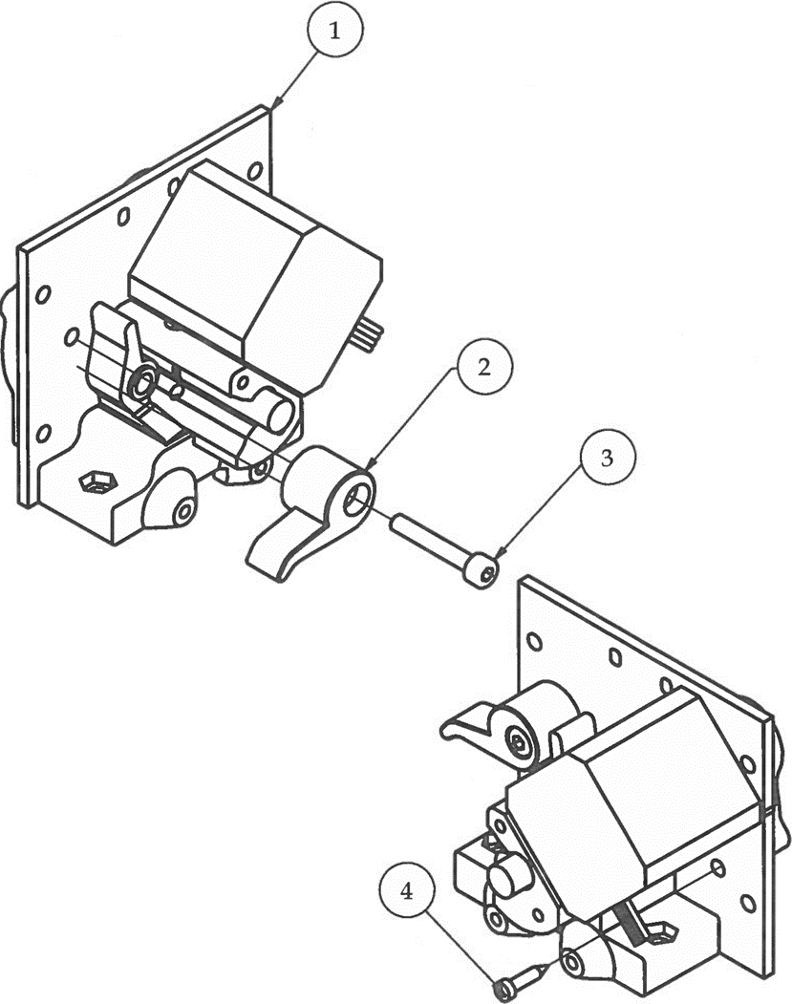Step 9

1. Poke hole through thin layer of plastic on cam1.
2. Attach cam1 using M4 x 25 bolt as shown.
3. CAUTION! Do not over tighten cam1 bolt. It should be loose enough that cam1 will move with pressure, but not be able to move freely. The cam will be the mechanism that holds pressure onto the filament that enables the filamentShaft to drive filament into the extruder's hotend.
4. Perform "Jiggle Test".
5. Attach last screw mounting gearbox6 using No. 4 x 1/2" screw.
6. Perform "Jiggle Test".

|  |  |  |  |
| --- | --- | --- | --- |
| **PARTS LIST** | | | |
| **ITEM** | **QTY** | **PART NUMBER** | **DESCRIPTION** |
| 1 | 1 | Step8 | Previous sub-assembly |
| 2 | 1 | cam1 | 3D printed part |
| 3 | 1 | M4 x 25 | Nuts and bolts |
| 4 | 1 | No.4 - 24 - 1/2 | Nuts and bolts |
|  |  | M3 Hex Wrench | Tools |
|  |  | Micro Phillips Screwdriver | Tools |

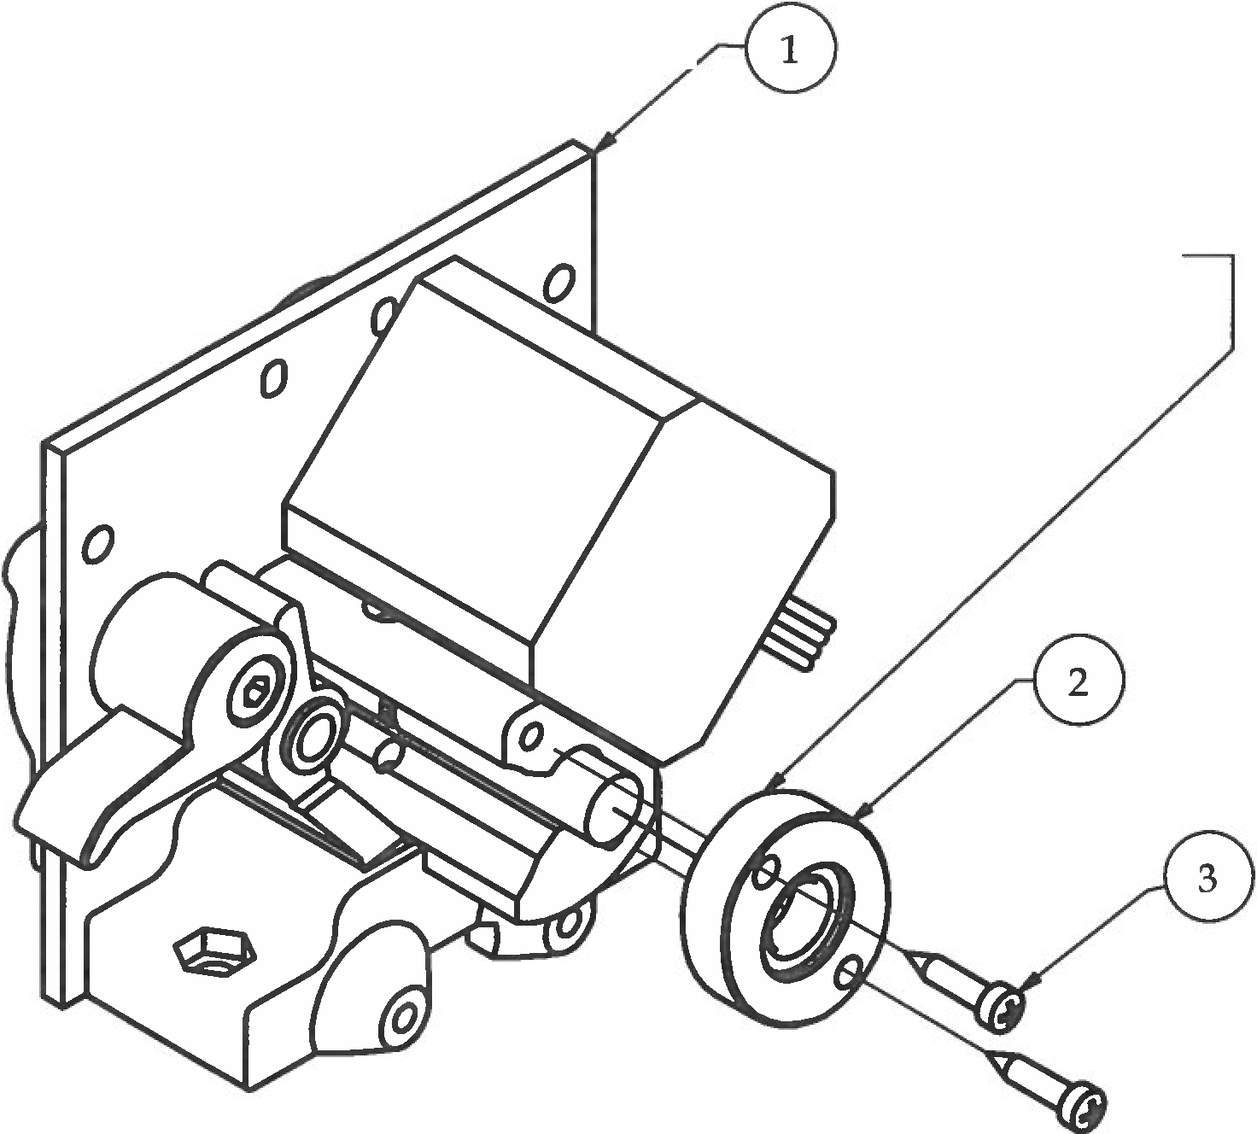Step 10

Bearing secured inside

1. Attach bearingCircle with bearing onto the end of extFrontCamV3 using (2) No. 4 x 1/ 2” screw. Make sure bearingCircle is oriented so the 688zz bearing is secured when assembled (if put on backwards, bearing can slide out).
2. CAUTION! Perform "Jiggle Test" as you tighten in screws. This step is critical in helping to align the filamentShaft and making it possible to float inside the extruder.
3. If the filamentShaft becomes unable to jiggle, reverse screws and try again.

|  |  |  |  |
| --- | --- | --- | --- |
| **PARTS LIST** | | | |
| **ITEM** | **QTY** | **PART NUMBER** | **DESCRIPTION** |
| 1 | 1 | Step9 | Previous sub-assembly |
| 2 | 1 | Step6.3 | Previous sub-assembly |
| 3 | 2 | No.4 - 24 - 1/2 | Nuts and bolts |
|  |  | Micro Phillips Screwdriver | Tools |

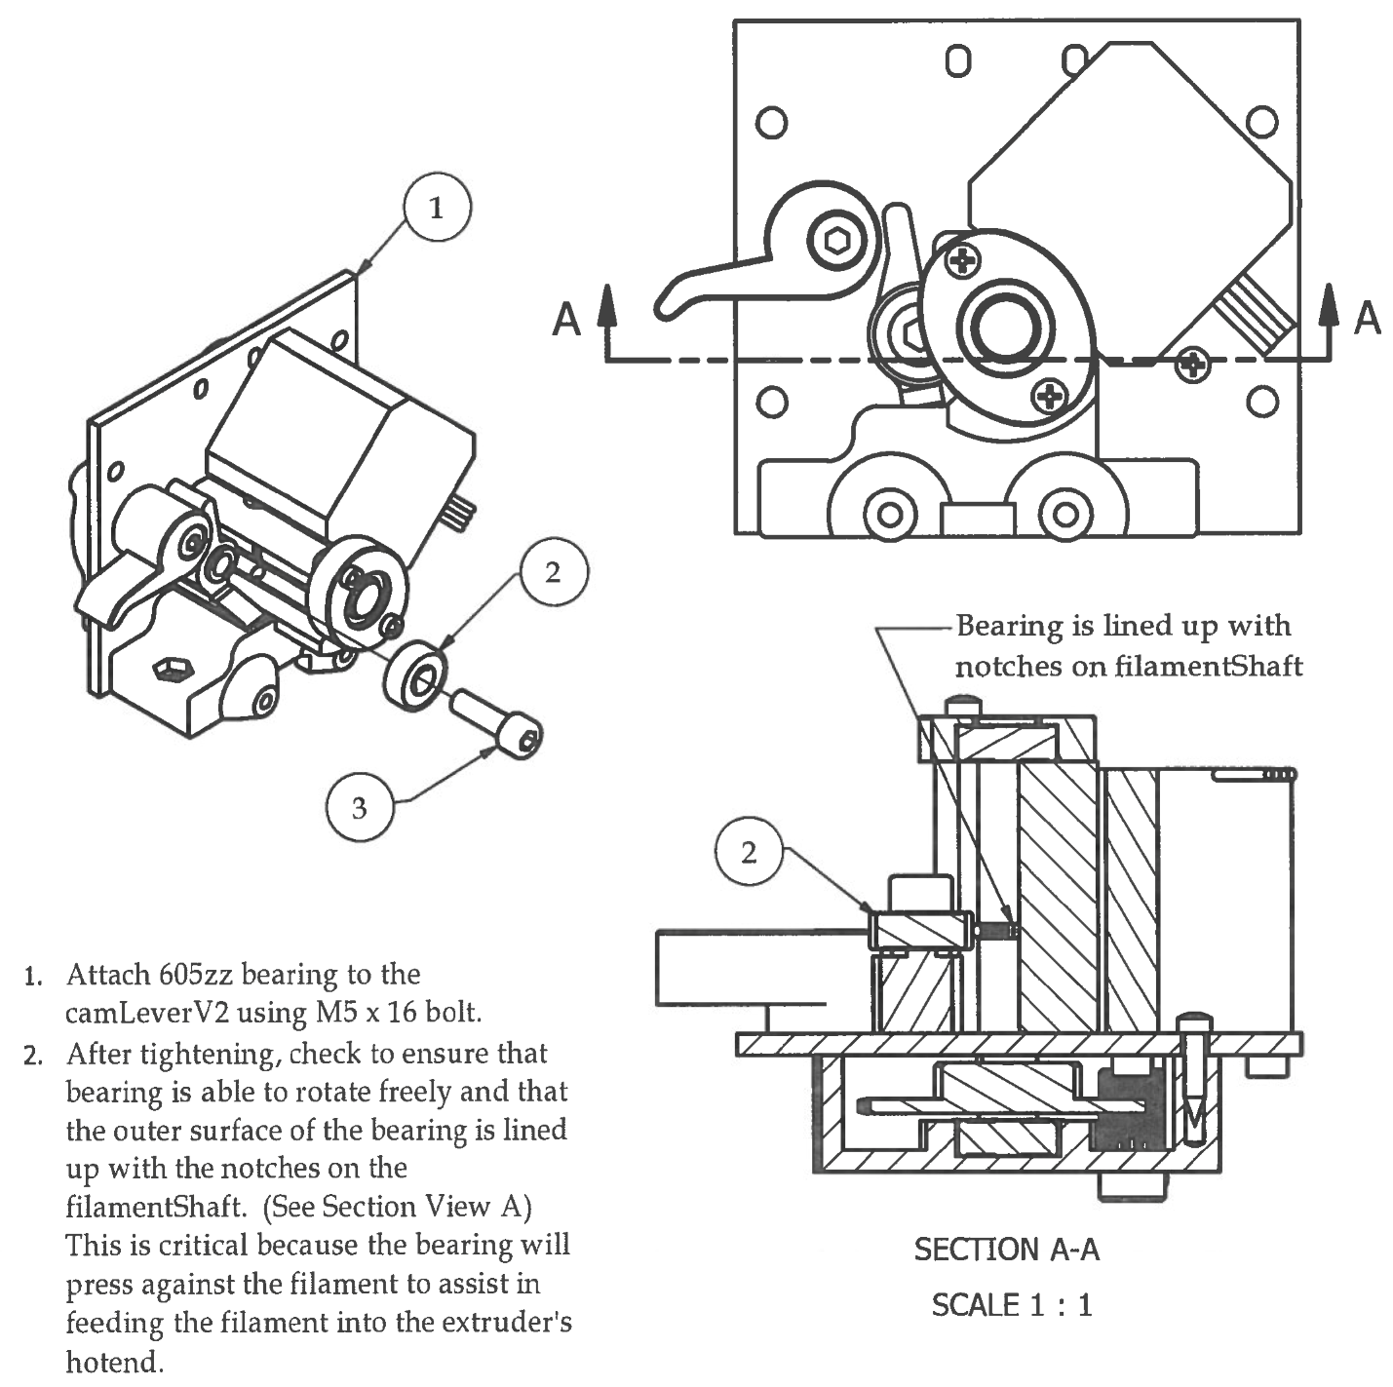Step 11

1. Attach 605zz bearing to the camLeverV2 using M5 x 16 bolt.
2. After tightening, check to ensure that bearing is able to rotate freely and that the outer surface of the bearing is lined up with the notches on the filamentShaft. (See Section View A) This is critical because the bearings will press against the filament to assist in feeding the filament into the extruder’s hotend.

|  |  |  |  |
| --- | --- | --- | --- |
| **PARTS LIST** | | | |
| **ITEM** | **QTY** | **PART NUMBER** | **DESCRIPTION** |
| 1 | 1 | Step10 | Previous sub-assembly |
| 2 | 1 | 605zz Bearing | Off-the-shelf components |
| 3 | 1 | M5 x 16 | Nuts and bolts |
|  |  | M4 Hex Wrench | Tools |

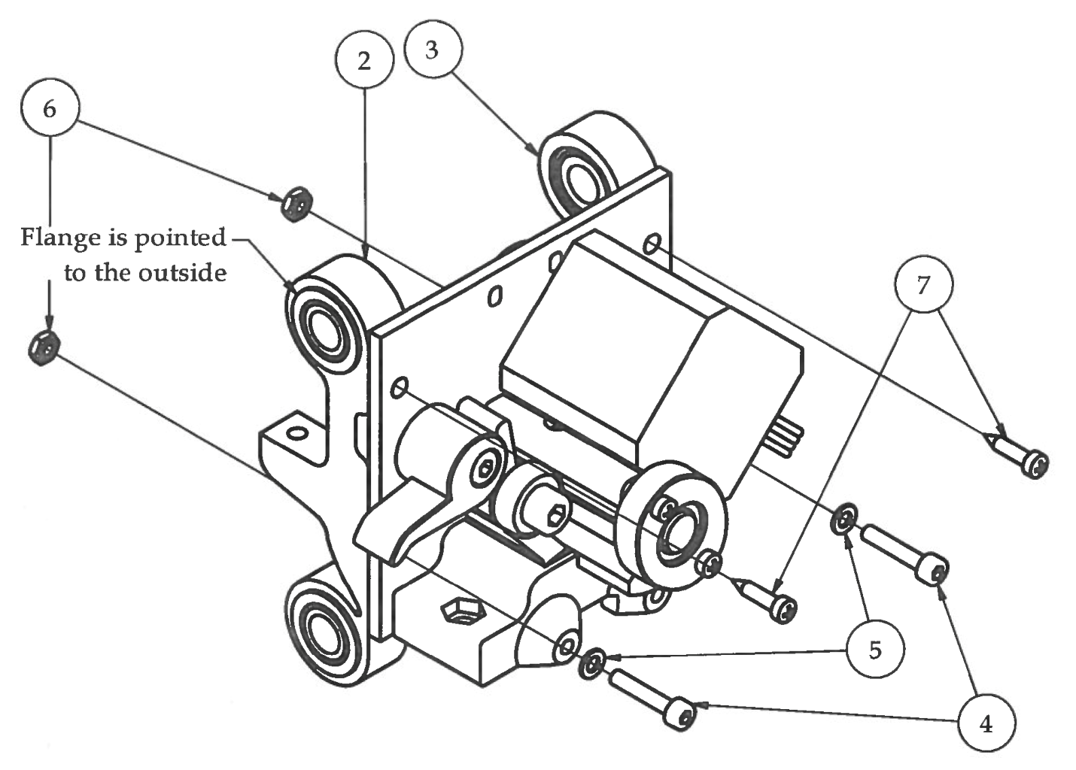Step 12

1. Attach xCarriageV2 brackets to the back of extPlateV3 as shown with the flange of the 8mm bronze bushings facing outwards.

|  |  |  |  |
| --- | --- | --- | --- |
| **PARTS LIST** | | | |
| **ITEM** | **QTY** | **PART NUMBER** | **DESCRIPTION** |
| 1 | 1 | Step11 | Previous sub-assembly |
| 2 | 1 | xCarriageV2right | Previous sub-assembly |
| 3 | 1 | xCarriageV2left | Previous sub-assembly |
| 4 | 2 | M3 x 16 | Nuts and bolts |
| 5 | 2 | M3 Washer | Nuts and bolts |
| 6 | 2 | M3 Nut | Nuts and bolts |
| 7 | 2 | No.4 - 24 - 3/8 | Nuts and bolts |
|  |  | M2.5 Hex Wrench | Tools |
|  |  | Micro Phillips Screwdriver | Tools |

1. CAUTION! Do not tighten any hardware all the way! Leave a 2mm gap so that xCarriageV2 brackets can move around freely. The distance between them will be determined by attaching the xBeltBracketV2 plastic part in the next step.

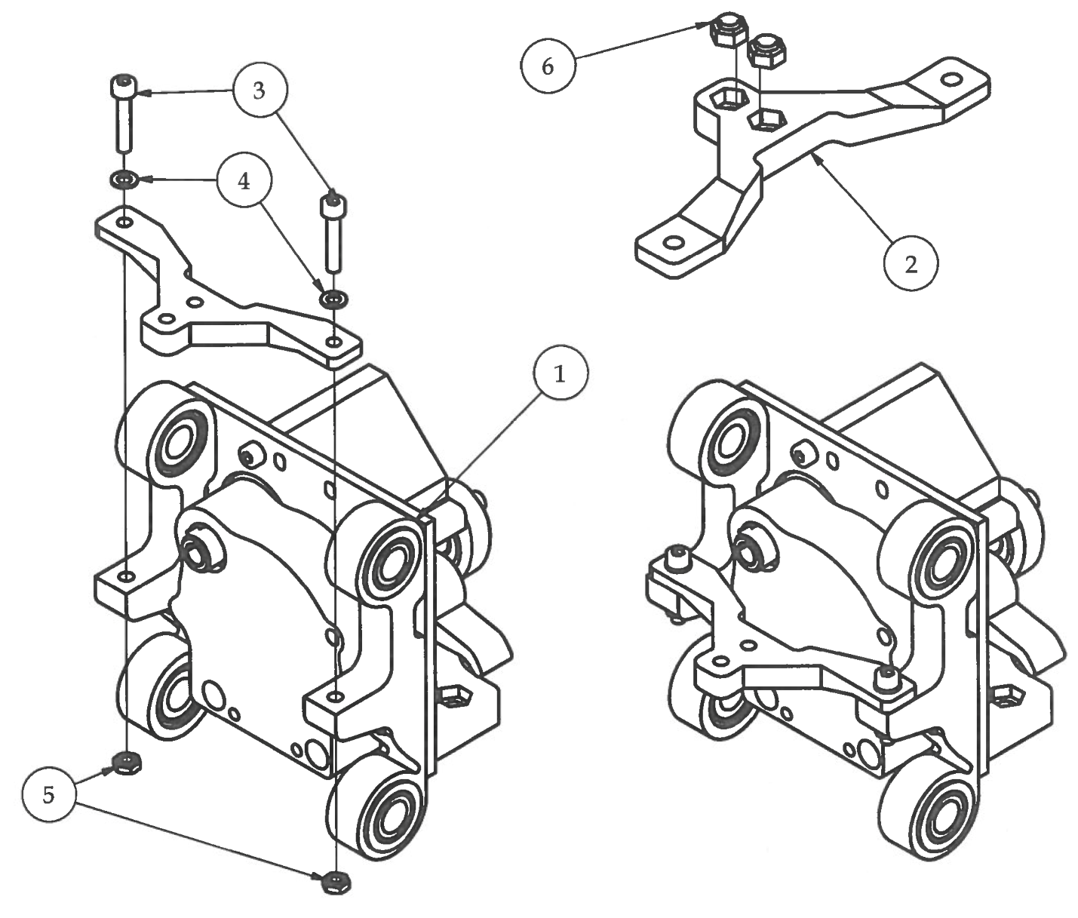Step 13

1. Press fit M3 Nylock nuts into hex cavity on xBeltBracketV2.
2. Attach xBeltBracketV2 to xCarriageV2 brackets with the M3 Nylock nuts facing towards the bottom as shown.

|  |  |  |  |
| --- | --- | --- | --- |
| **PARTS LIST** | | | |
| **ITEM** | **QTY** | **PART NUMBER** | **DESCRIPTION** |
| 1 | 1 | Step12 | Previous sub-assembly |
| 2 | 1 | xBeltBracketV2 | 3D printer part |
| 3 | 2 | M3 x 16 | Nuts and bolts |
| 4 | 2 | M3 Wahser | Nuts and bolts |
| 5 | 2 | M3 Nut | Nuts and bolts |
| 6 | 2 | M3 Nylock nut | Nuts and bolts |
|  |  | M2.5 Hex Wrench | Tools |

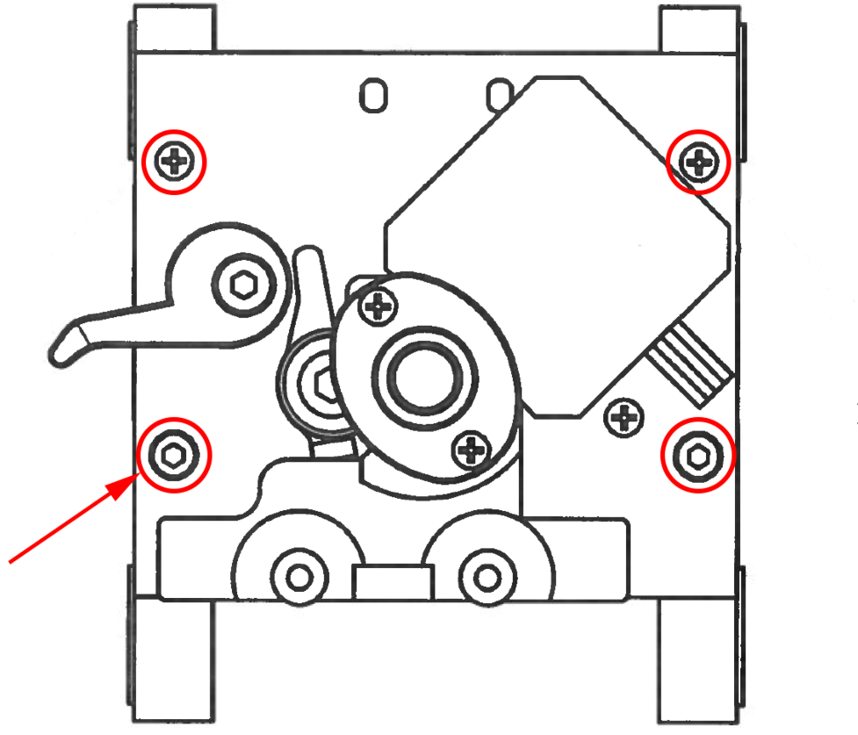Step 14

Completely tighten xCarriageV2 hardware to extPlateV3 on both sides

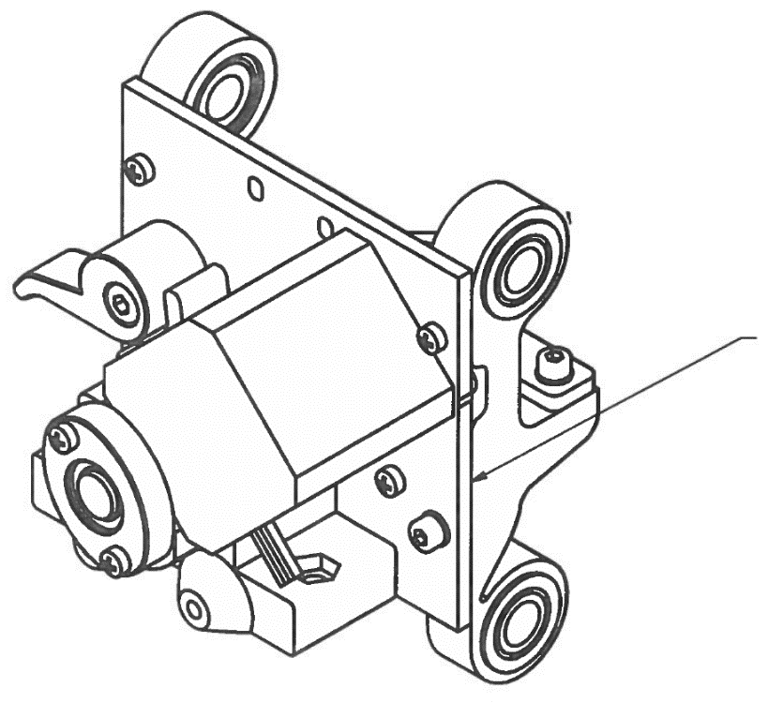

xCarriageV2 edge

PARALLEL to

extPlateV3 edge

1. Slide the 8mm smooth rods into the Bonze Bushings on the back of the Extruder.
2. Align the edge of one of the xCarriageV2 brackets parallel to the edge of the extPlaveV3. The xCarriageV2 bracket does not have to be flush with extPlateV2 You should split the difference from either sides. What is really important before tightening these screws is that the xCarriageV2 brackets are PARALLEL to the edge of the extPlateV2.

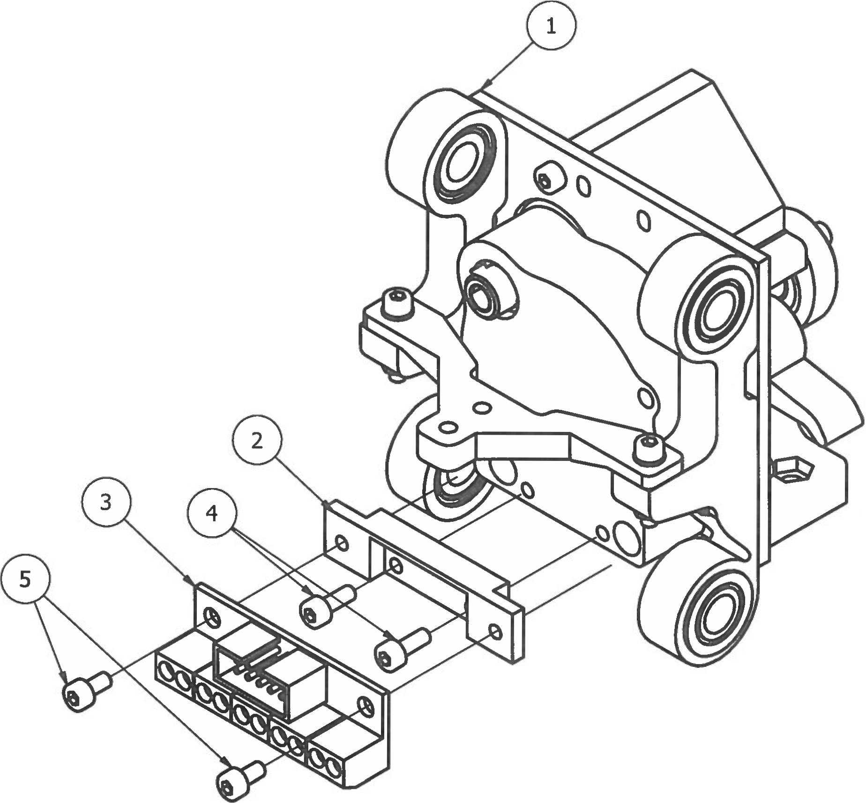Step 15

1. Attach connectorBracketV2 to lower, inner holes on back of gearbox6 using M3 x 8mm bolts. Bolts will self-tap into plastic. Do not over tighten!

|  |  |  |  |
| --- | --- | --- | --- |
| **PARTS LIST** | | | |
| **ITEM** | **QTY** | **PART NUMBER** | **DESCRIPTION** |
| 1 | 1 | Step14 | Previous sub-assembly |
| 2 | 1 | connectorBracketV2 | 3D printed part |
| 3 | 1 | M3 x 8 | Electrical components |
| 4 | 2 | M3 x 6 | Nuts and bolts |
| 5 | 2 | M2.5 Hex Wrench | Nuts and bolts |
|  |  |  | Tools |

1. Attach 10pinBreakOutBoard using (2) M3 x 6 bolts, again self-tapping the bolts into plastic part. Be careful not to over tighten!

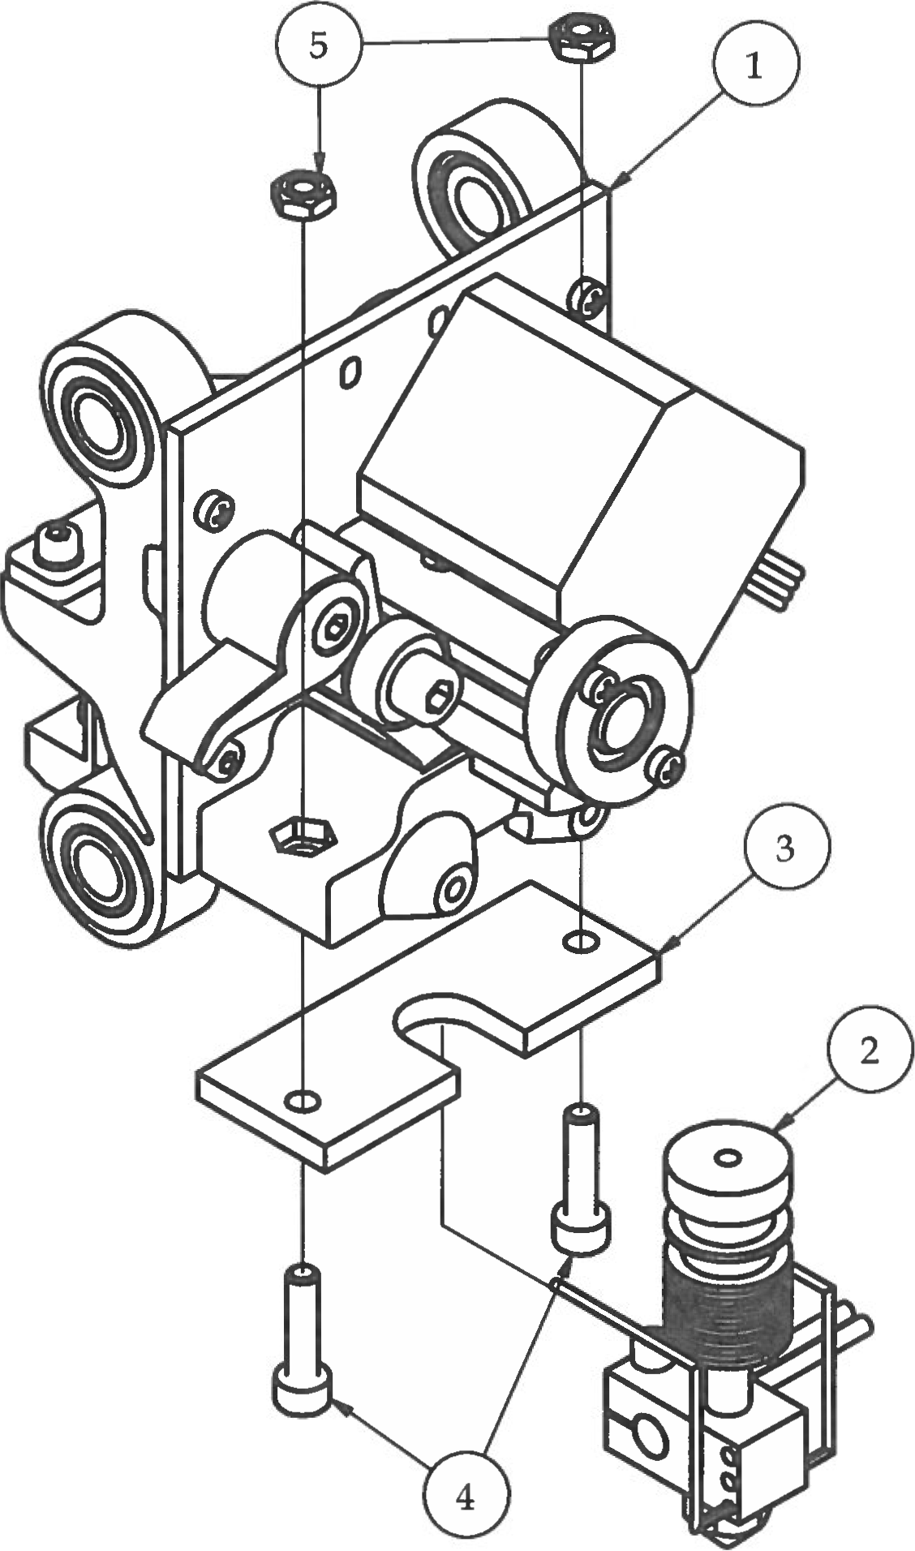Step 16

1. Attach the pre-assembled hotEnd to the extruder using the hotEndPlate, (2) M4 x 16 bolts, and (2) M4 nuts.
2. CAUTION! Make sure that hotEndPlate is oriented as shown in drawing. Mounting holes are offset to install with open slot facing outward.

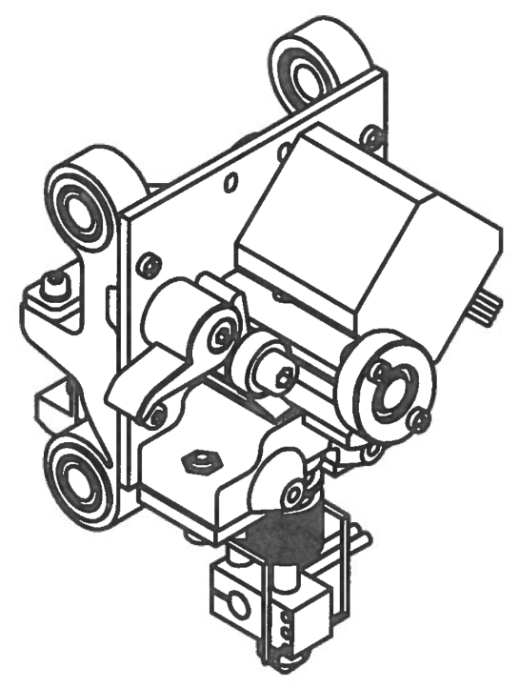

|  |  |  |  |
| --- | --- | --- | --- |
| **PARTS LIST** | | | |
| **ITEM** | **QTY** | **PART NUMBER** | **DESCRIPTION** |
| 1 | 1 | Step15 | Previous sub-assembly |
| 2 | 1 | hotEndComplete | Previous sub-assembly |
| 3 | 1 | hotEndPlateV2 | Custom aluminum part |
| 4 | 2 | M4 x 16 | Nuts and bolts |
| 5 | 2 | M4 Nut | Nuts and bolts |
|  |  | M3 Hex Wrench | Tools |

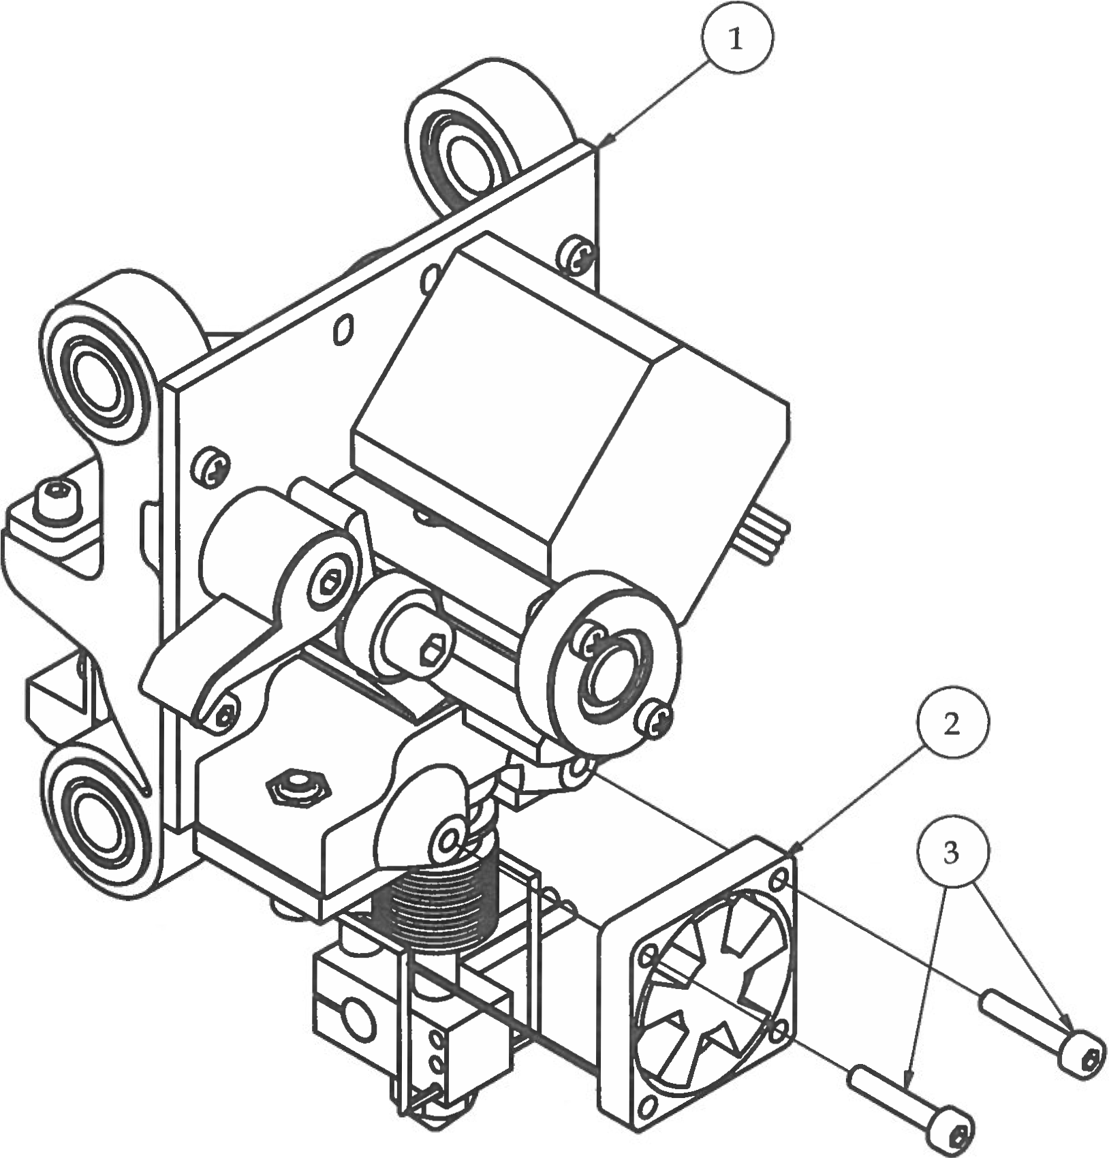Step 17

1. Install the 30mm Box Fan with sticker facing towards the back of extruder, thus pointing air flow towards the hot end.

|  |  |  |  |
| --- | --- | --- | --- |
| **PARTS LIST** | | | |
| **ITEM** | **QTY** | **PART NUMBER** | **DESCRIPTION** |
| 1 | 1 | Step16 | Previous sub-assembly |
| 2 | 1 | 30mm Box Fan | Electrical components |
| 3 | 2 | M3 x 16 | Nuts and bolts |
|  |  | M2.5 Hex Wrench | Tools |

1. The wires from the 30mm box fan should be sticking out towards the lower left side of the fan. Use (2) M3 x 16 bolts. Bolts will self-tap into the plastic part. Do *NOT* over tighten!

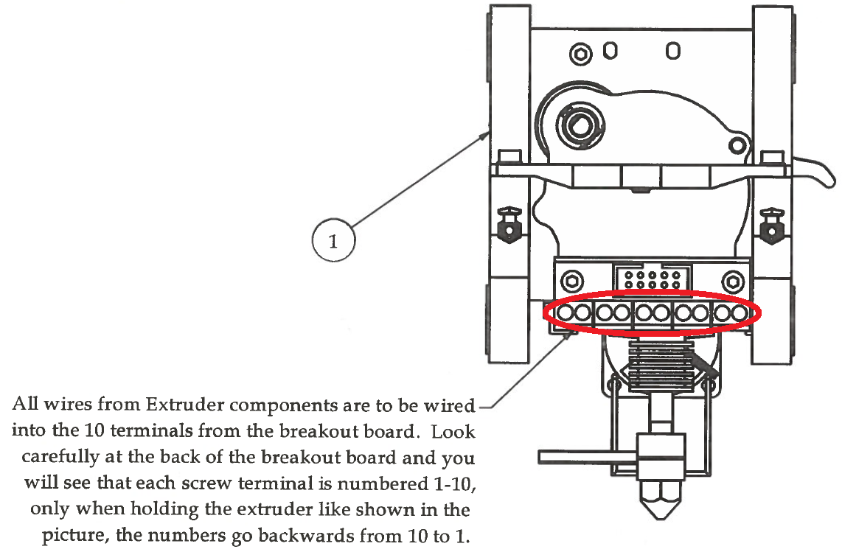Step 18

All wires from Extruder components are to be wired into the 10 terminals from the breakout board. Look carefully at the back of the breakout board and you will see that each screw terminal is numbered 1-10, only **when holding the extruder like shown in the picture, the numbers go backwards from 10 to 1.**

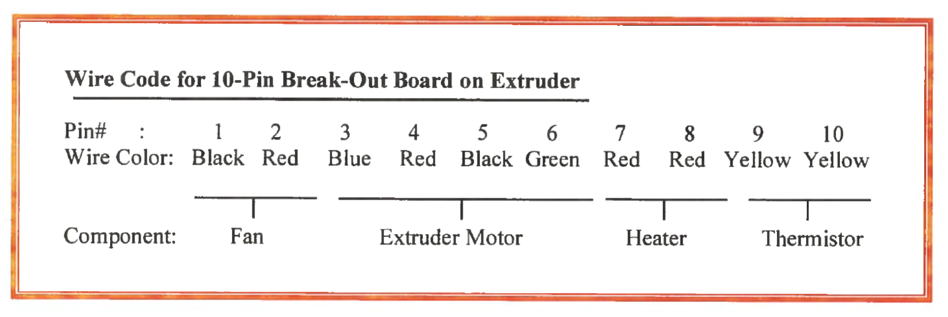

|  |  |  |  |
| --- | --- | --- | --- |
| **PARTS LIST** | | | |
| **ITEM** | **QTY** | **PART NUMBER** | **DESCRIPTION** |
| 1 | 1 | Step17 | Previous sub-assembly |
|  |  | Micro Flathead Screwdriver | Tools |

# **Bottom Frame Assembly**

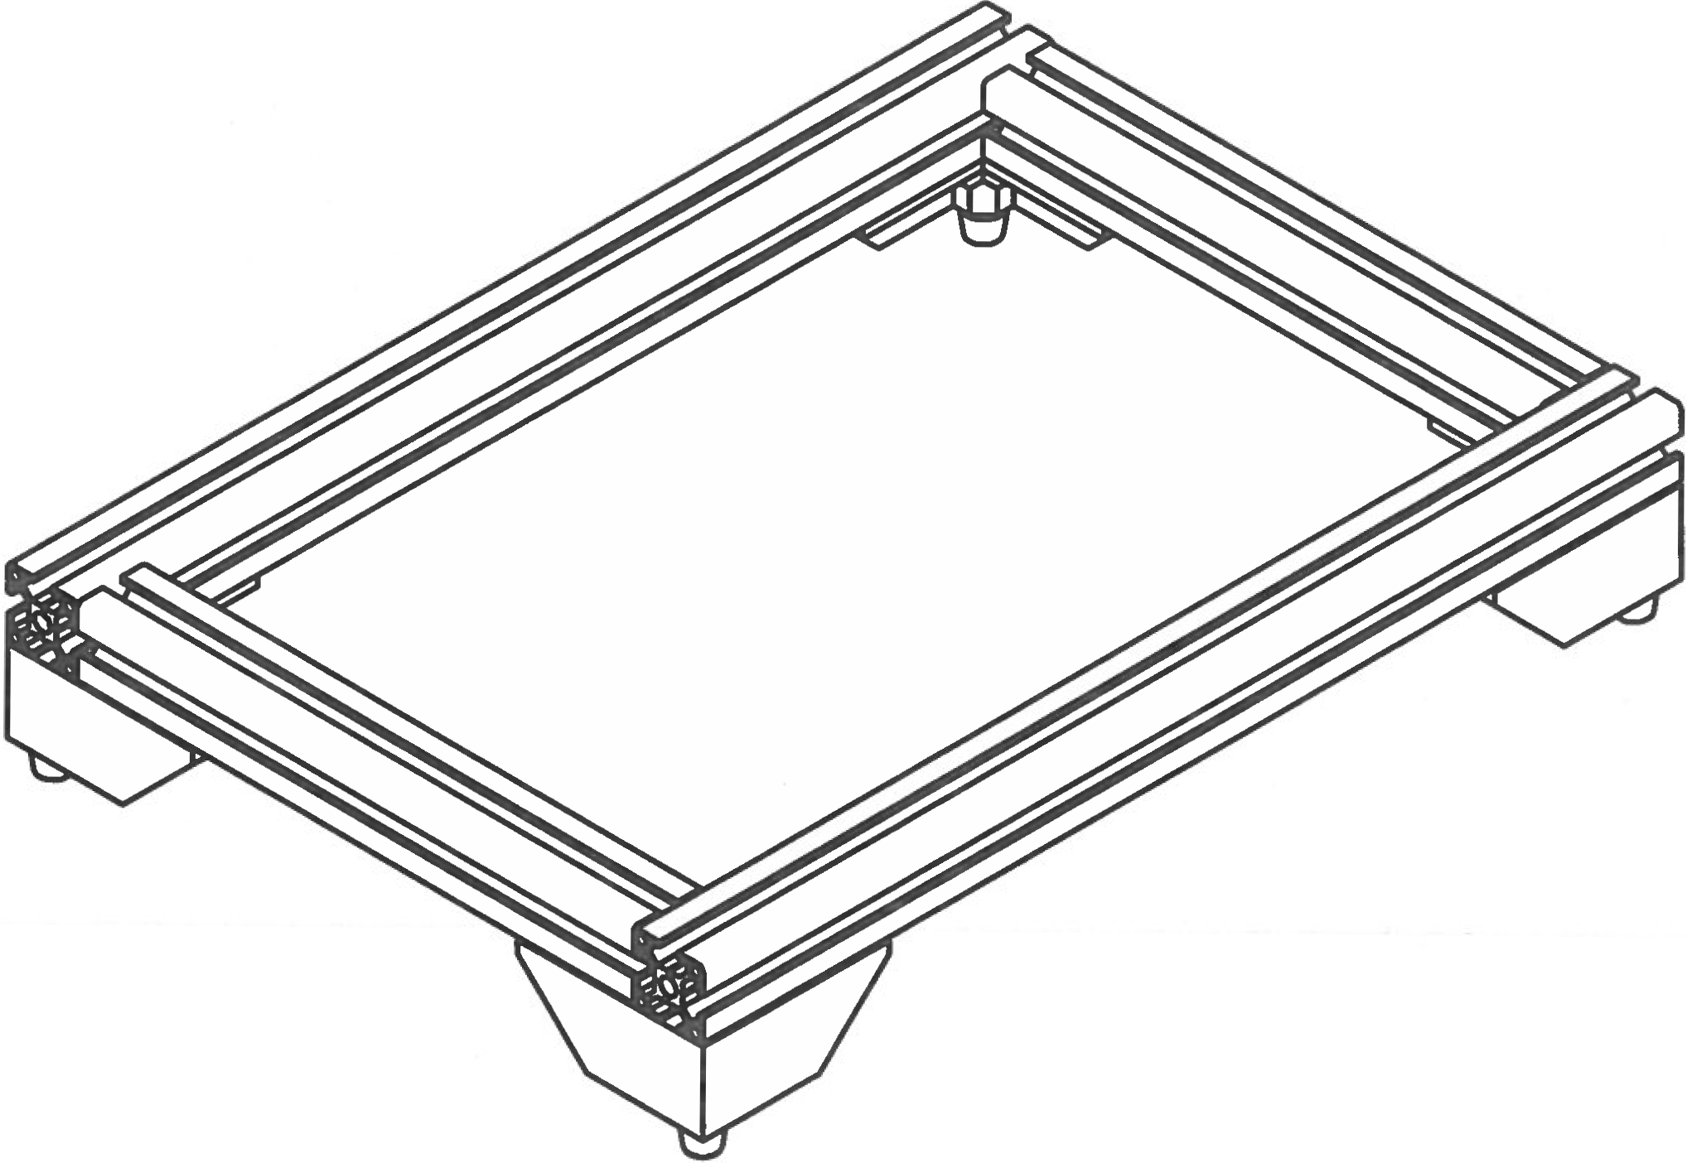

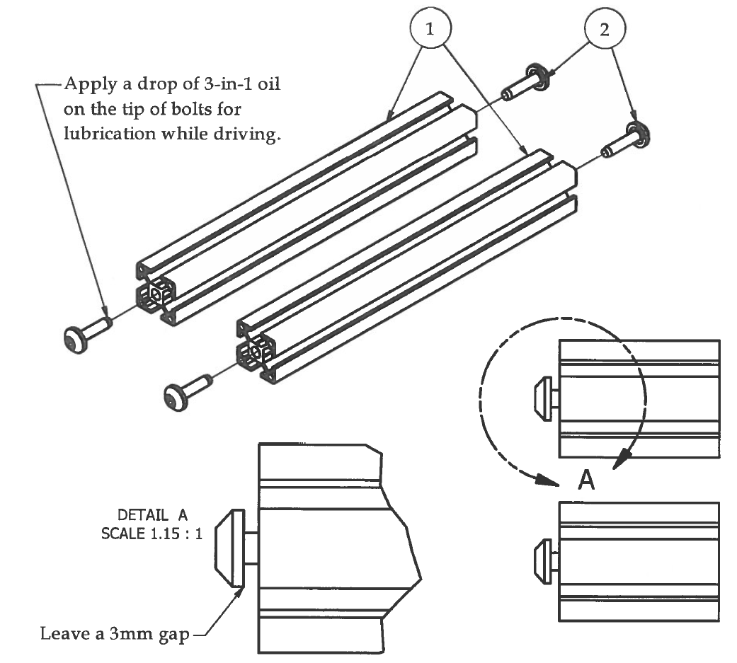Step 1

1. Drive the HTJ6 self-tapping bolts into the holes on the ends fo the 240mm aluminum extrusions suing a TORX T40 driver. Apply 1 drop of 3-in-1 oil to the tip of the bolt for lubrication.
2. *LEAVE A 3mm GAP* between the head of the bolt and the edge of the aluminum extrusion!

|  |  |  |  |
| --- | --- | --- | --- |
| **PARTS LIST** | | | |
| **ITEM** | **QTY** | **PART NUMBER** | **DESCRIPTION** |
| 1 | 2 | Step 1 | Previous sub-assembly |
| 2 | 1 | Aluminum extrusion 3030 366mm | Off-the-shelf component |
|  |  | TORX T40 Driver | Tools |

Step 2

1. Lay out the 4 aluminum extrusions for the bottom frame assembly as shown.
2. Make sure the Tool Access Holes on the left and right extrusions are horizontally accessible.
3. Place T-Nuts into the slots that will be inaccessible when bottom frame is put together. *** MAKE SURE YOU PLACE THE RIGHT NUMBER OFT-NUTS INTO THE RIGHT SLOTS*** Forgetting or misplacing a T-Nut at this step will require almost complete disassembly of the flexMendel later to fix the mistake.

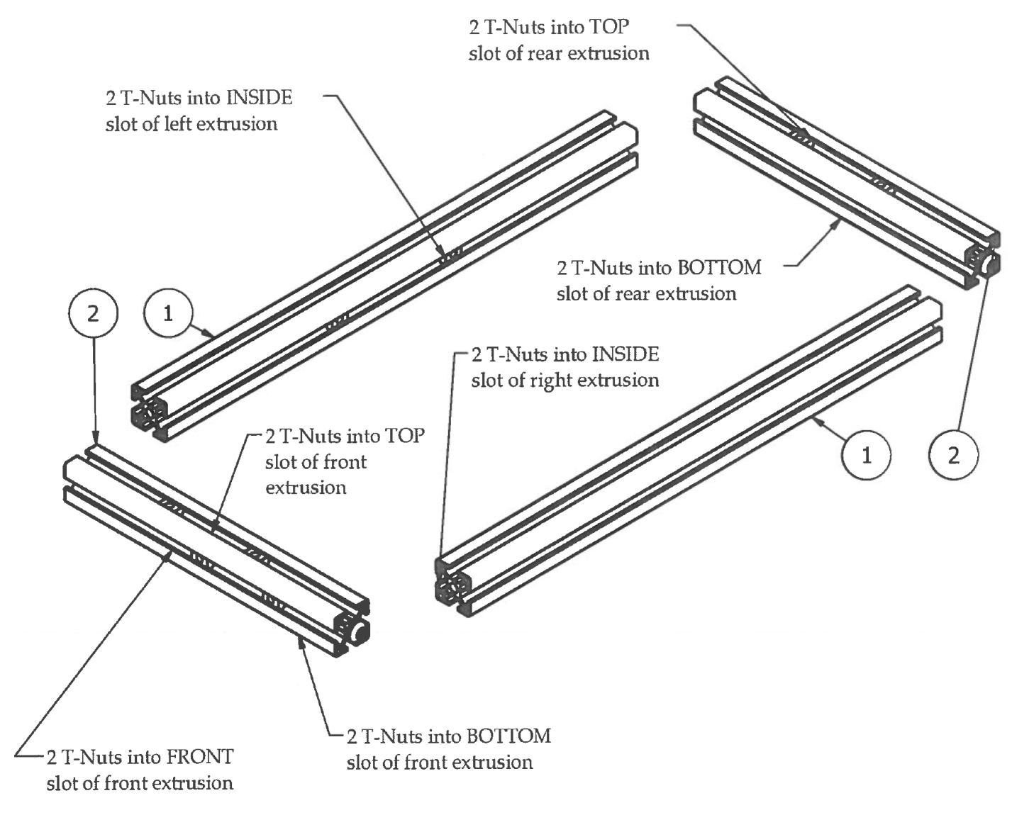

|  |  |  |  |
| --- | --- | --- | --- |
| **PARTS LIST** | | | |
| **ITEM** | **QTY** | **PART NUMBER** | **DESCRIPTION** |
| 1 | 2 | Aluminum Extrusion 3030 420mm | Off-the-shelf components |
| 2 | 2 | Step 1.1 | Previous sub-assembly |
| 3 | 14 | M5 T-Nut | Nuts and bolts |

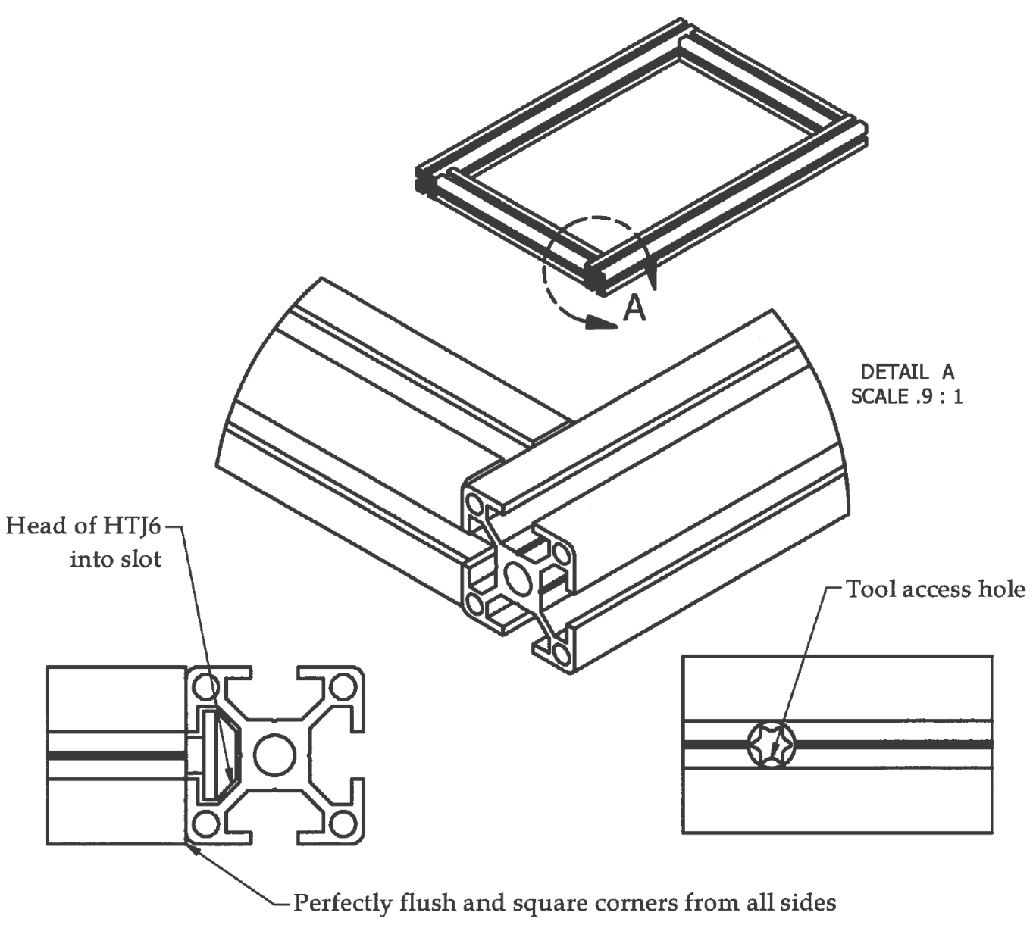Step 3

1. Ensure that the aluminum extrusions are sitting on a level work surface.
2. Carefully slide the extrusions together by inserting the head of the HTJ6 blind bolt into the slot of the adjacent extrusion.
3. Square up the edges of the corner you are about to tighten from all sides.
4. Using the TORX T40 driver, access the HTJ6 blind bolt through the tool access hole on the sides of the left and right extrusions.
5. When you tighten the HTJ6 blind bolts to the frame, keep a close eye on the squareness of each corner. You want all sides to be perfectly flush after tightening all the way.

|  |  |  |  |
| --- | --- | --- | --- |
| **PARTS LIST** | | | |
| **ITEM** | **QTY** | **PART NUMBER** | **DESCRIPTION** |
|  |  | TORX T40 Driver | Tools |

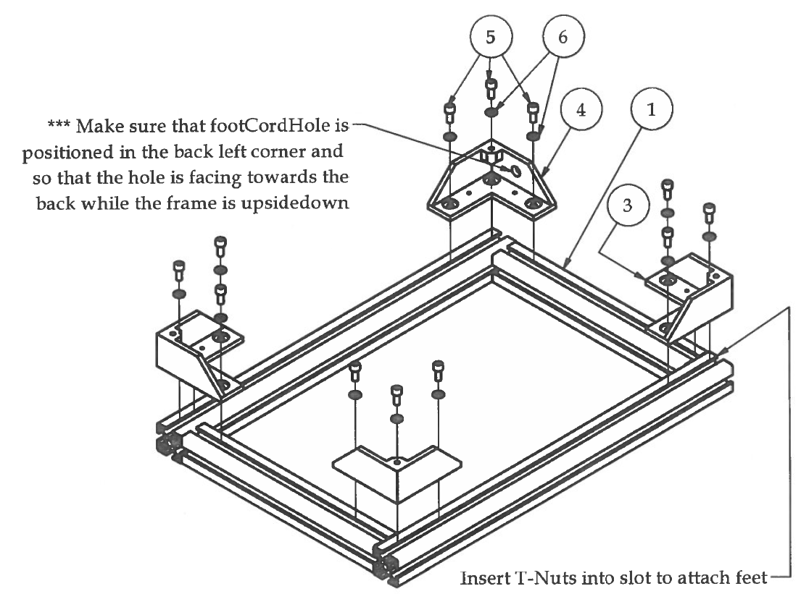Step 4

*** Take note of the Front and Back of the frame. The front is distinguished with the extra 2 T-Nuts in the front slot of the front extrusion.***

1. Insert 8 additional T-Nuts into slots of left and right extrusions, 4 on each side.
2. Use the existing 4 T-Nuts (2 in the front and 2 in the back) to mount the feet to the bottom frame.
3. Make sure that the footCordHole is in the back-left of the frame with the cord hole facing to the back when the bottom frame is upside down.

|  |  |  |  |
| --- | --- | --- | --- |
| **PARTS LIST** | | | |
| **ITEM** | **QTY** | **PART NUMBER** | **DESCRIPTION** |
| 1 | 1 | Bottom frame | Previous sub-assembly |
| 2 | 8 | M5 T-Nut | Nuts and bolts |
| 3 | 3 | foot | 3D printed part |
| 4 | 1 | footCordHole | 3D printed part |
| 5 | 12 | M5 x 12 | Nuts and bolts |
| 6 | 12 | M5 Washer | Nuts and bolts |
|  |  | M4 Hex Wrench | Tools |

Step 5

|  |  |  |  |
| --- | --- | --- | --- |
| **PARTS LIST** | | | |
| **ITEM** | **QTY** | **PART NUMBER** | **DESCRIPTION** |
| 1 | 1 | Step 4 | Previous sub-assembly |
| 2 | 4 | rubberFoot | Off-the-shelf component |
| 3 | 4 | #8 x 3/4 | Nuts and bolts |
|  |  | Medium Phillips Screwdriver | Tools |

1. Attach rubber feet to the bottom of the 3D printed feet. This will help keep the 3D printer secure during operation.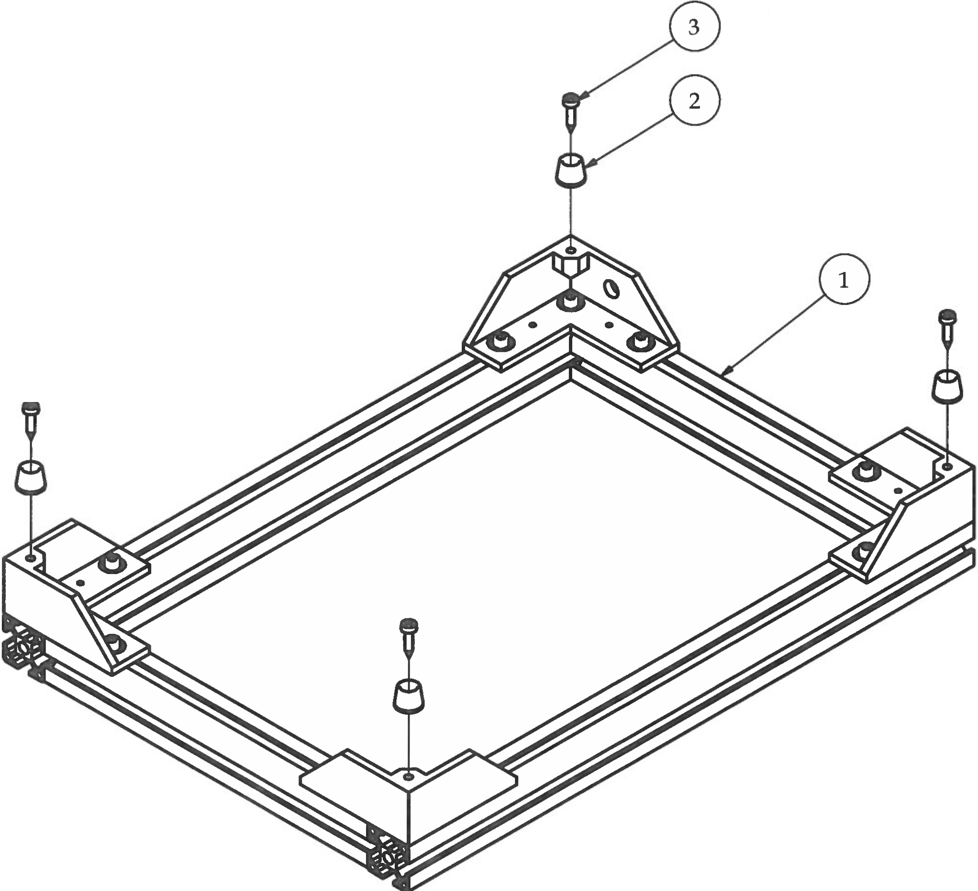

# **Upright Frame Assembly**

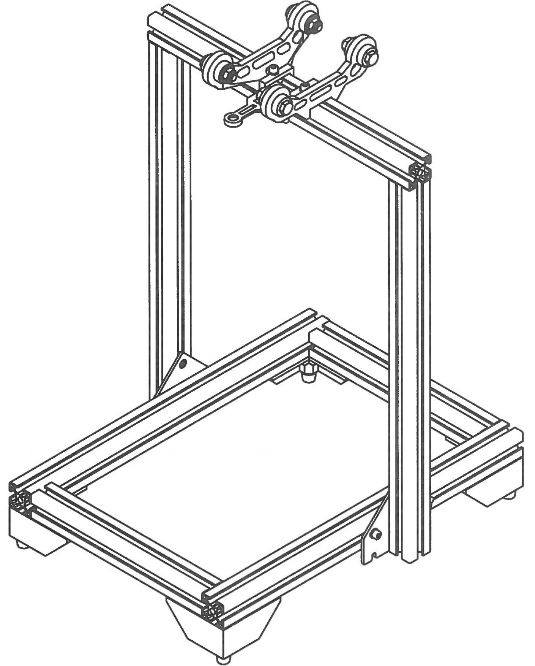

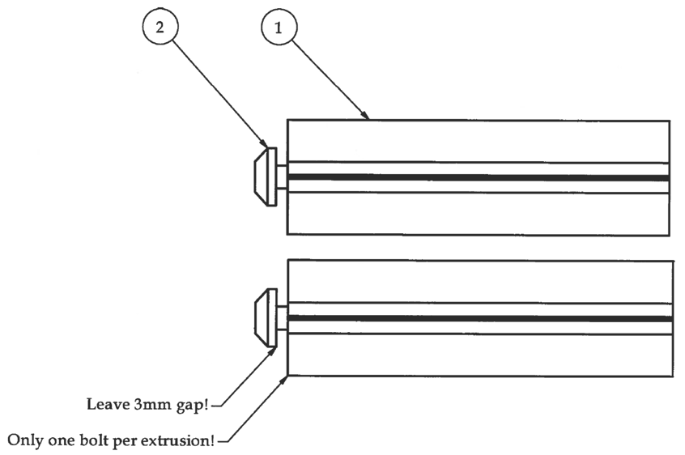Step 1

1. Prepare the upright aluminum extrusions for assembly by driving the HTJ6 self-tapping blind bolts into the hole on one end.
2. Use a drop of 3-in-1 oil for lubrication.
3. Make sure to leave a 3mm gap between the head of the bolt and the end of the extrusion.

|  |  |  |  |
| --- | --- | --- | --- |
| **PARTS LIST** | | | |
| **ITEM** | **QTY** | **PART NUMBER** | **DESCRIPTION** |
| 1 | 2 | Aluminum Extrusion 3030-450mm | Off-the-shelf component |
| 2 | 2 | HTJ6 Self-tapping Blind Bolt | Nuts and bolts |
|  |  | TORX T40 Driver | Tools |

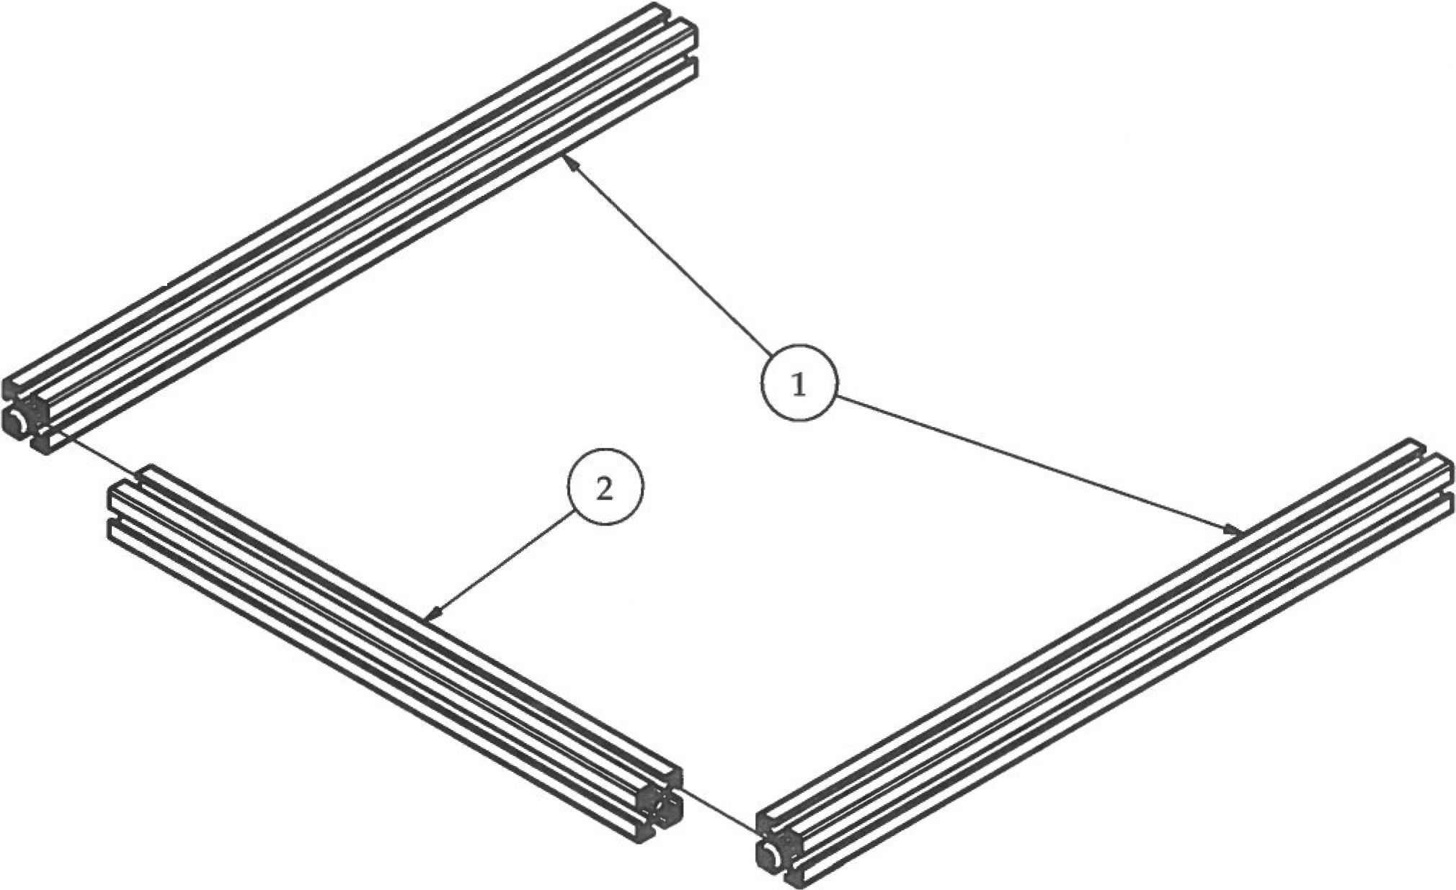Step 2

1. Lay upright and top crossbar aluminum extrusions out on a flat work surface.
2. *** The upright aluminum extrusions need to be oriented so that the slot that was fitted for the zSlides are facing to the outside of the upright frame. Small differences in the widths of the slots on the aluminum extrusions could potentially affect smoothness of sliding action!
3. Use the X-StageSupport and X-StageSupportMotor sub-assemblies to test and identify the correct slot that should be used for the slides and place them to the outside.
4. After identifying both zSlide slots, carefully slide the extrusions together by inserting the head of the HTJ6 blind bolt into the slot of the adjacent extrusion.
5. Square up the edges of the corner you are about to tighten from all sides.
6. Using the TORX T40 driver, access the HTJ6 blind bolt through the tool access hole on the top of the crossbar extrusion.
7. When you tighten the HTJ6 blind bolts to the frame, keep a close eye on the squareness of each corner. You want all sides to be perfectly flush after tightening all the way.

|  |  |  |  |
| --- | --- | --- | --- |
| **PARTS LIST** | | | |
| **ITEM** | **QTY** | **PART NUMBER** | **DESCRIPTION** |
| 1 | 2 | Step 1 | Previous sub-assembly |
| 2 | 1 | Aluminum extrusion 3030 366mm | Off-the-shelf component |
|  |  | TORX T40 Driver | Tools |

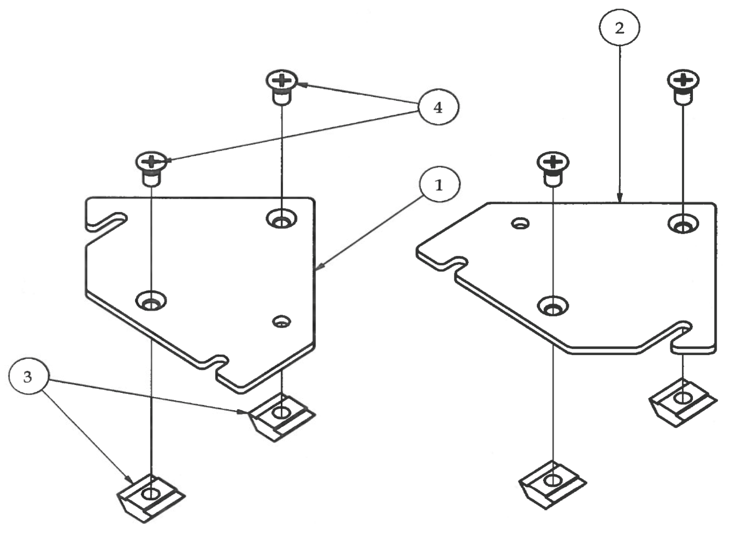Step 3

1. Prepare the zBrackets, Left and Right, by loosely assembling the M5 countersink machine screws to the M5 T-Nuts.
2. Leave at least a 2mm gap between the T-Nut and the zBracket plates to allow them to slide into the slots on the upright aluminum extrusions.

|  |  |  |  |
| --- | --- | --- | --- |
| **PARTS LIST** | | | |
| **ITEM** | **QTY** | **PART NUMBER** | **DESCRIPTION** |
| 1 | 1 | zBracketRight_AL | Custom aluminum part |
| 2 | 1 | zBracketLeft_AL | Custom aluminum part |
| 3 | 4 | M5 T-Nut | Nuts and bolts |
| 4 | 4 | M5 x 10 Countersink Machine screw | Nuts and bolts |

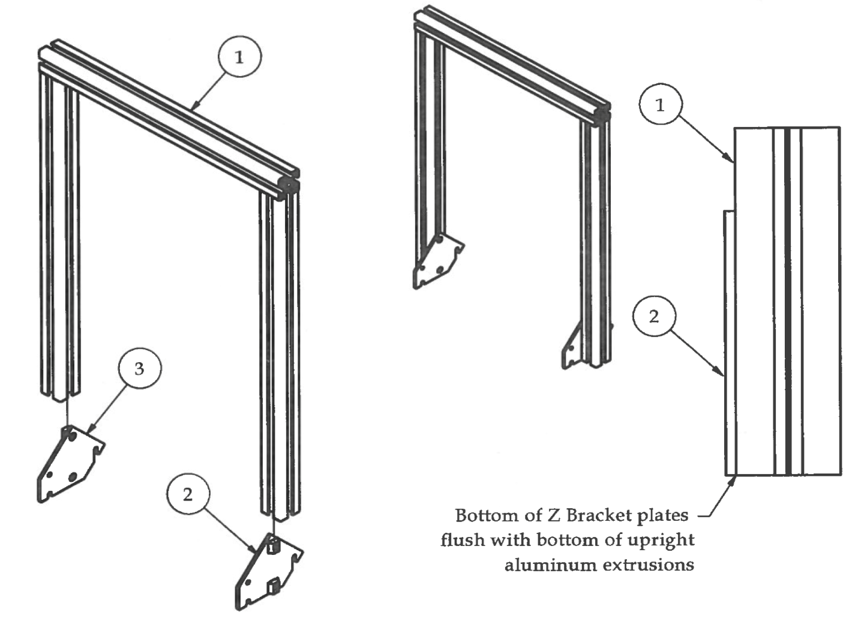Step 4

1. Slide the Z Brackets into the inside slots of the upright frame. When looking at the Z Brackets, the side that has the edge that is vertical will be towards the front of the flexMendel 3D printer. Make sure that zBracketLeft goes on the inside left slot and zBracketRight goes on the inside right slot as shown in the picture.
2. Set the upright frame onto a flat work surface as shown in the smaller picture before tightening the M5 countersink screws. The bottom of the Z Brackets should be flush with the bottom of the upright aluminum extrusions.
3. Securely tighten the M5 countersink screws.

|  |  |  |  |
| --- | --- | --- | --- |
| **PARTS LIST** | | | |
| **ITEM** | **QTY** | **PART NUMBER** | **DESCRIPTION** |
| 1 | 1 | Step 2 | Previous sub-assembly |
| 2 | 1 | zBracketRight | Previous sub-assembly |
| 3 | 1 | zBracketLeft | Previous sub-assembly |
|  |  | Medium Phillips Screwdriver | Tools |

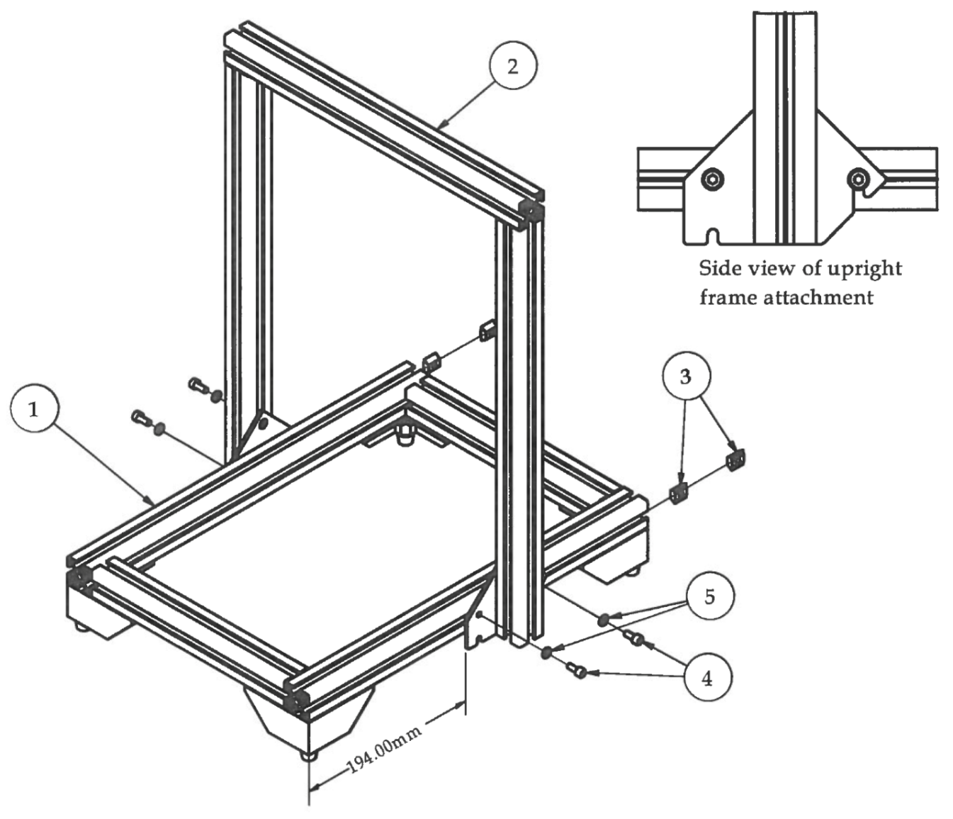Step 5

1. Insert 2 T-Nuts in outside slots of both left and right aluminum extrusions of the bottom frame.
2. Loosely insert M5 x 12 bolts through M5 washers into the T-Nuts. See the side view of upright frame attachment for detail.
3. Using a precision ruler, measure exactly 194mm from the front of the bottom frame
4. assembly to the front flat face of each Z Bracket before tightening down securely.

|  |  |  |  |
| --- | --- | --- | --- |
| **PARTS LIST** | | | |
| **ITEM** | **QTY** | **PART NUMBER** | **DESCRIPTION** |
| 1 | 1 | bottomFrameAssembly | Previous sub-assembly |
| 2 | 1 | Step 4 | Previous sub-assembly |
| 3 | 4 | M5 T-Nut | Nuts and bolts |
| 4 | 4 | M5 x 12 | Nuts and bolts |
| 5 | 4 | M5 Washer | Nuts and bolts |
|  |  | M4 Hex Wrench | Tools |

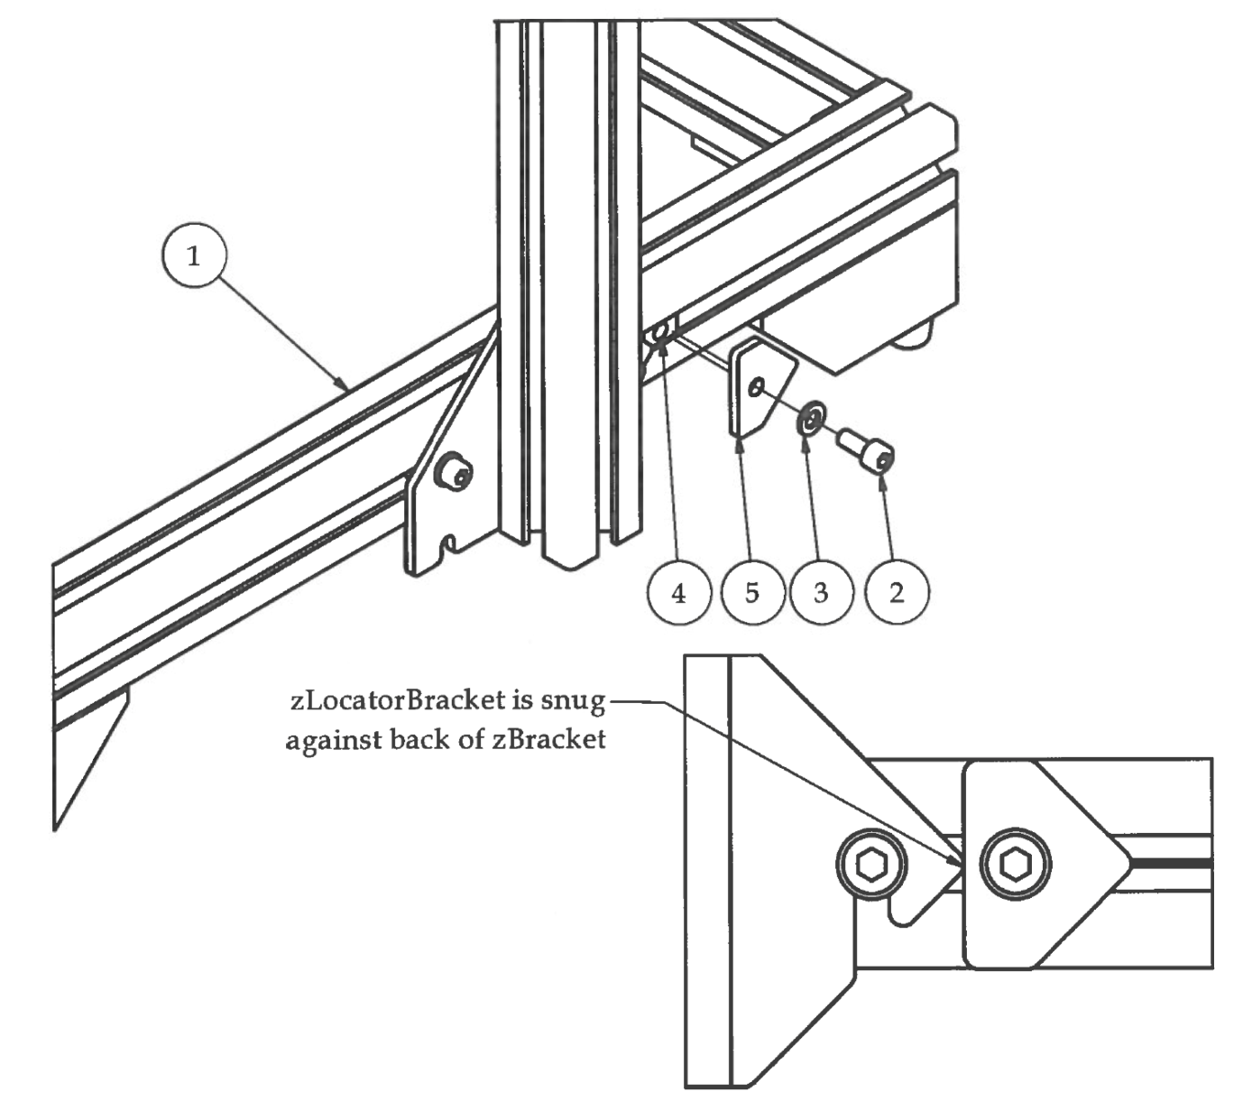Step 6

1. Attach Z locator brackets to the back of the zPlates of both sides of the upright frame as shown in the picture. This helps to identify the correct position of the upright frame if the flexMendel printer is folded for transportation.

|  |  |  |  |
| --- | --- | --- | --- |
| **PARTS LIST** | | | |
| **ITEM** | **QTY** | **PART NUMBER** | **DESCRIPTION** |
| 1 | 1 | Step 5 | Previous sub-assembly |
| 2 | 2 | M5 x 12 | Nuts and bolts |
| 3 | 2 | M5 Washer | Nuts and bolts |
| 4 | 2 | M5 T-Nut | Nuts and bolts |
| 5 | 2 | zLocatorbkt | 3D printed parts |
|  |  | M4 Hex Wrench | Tools |

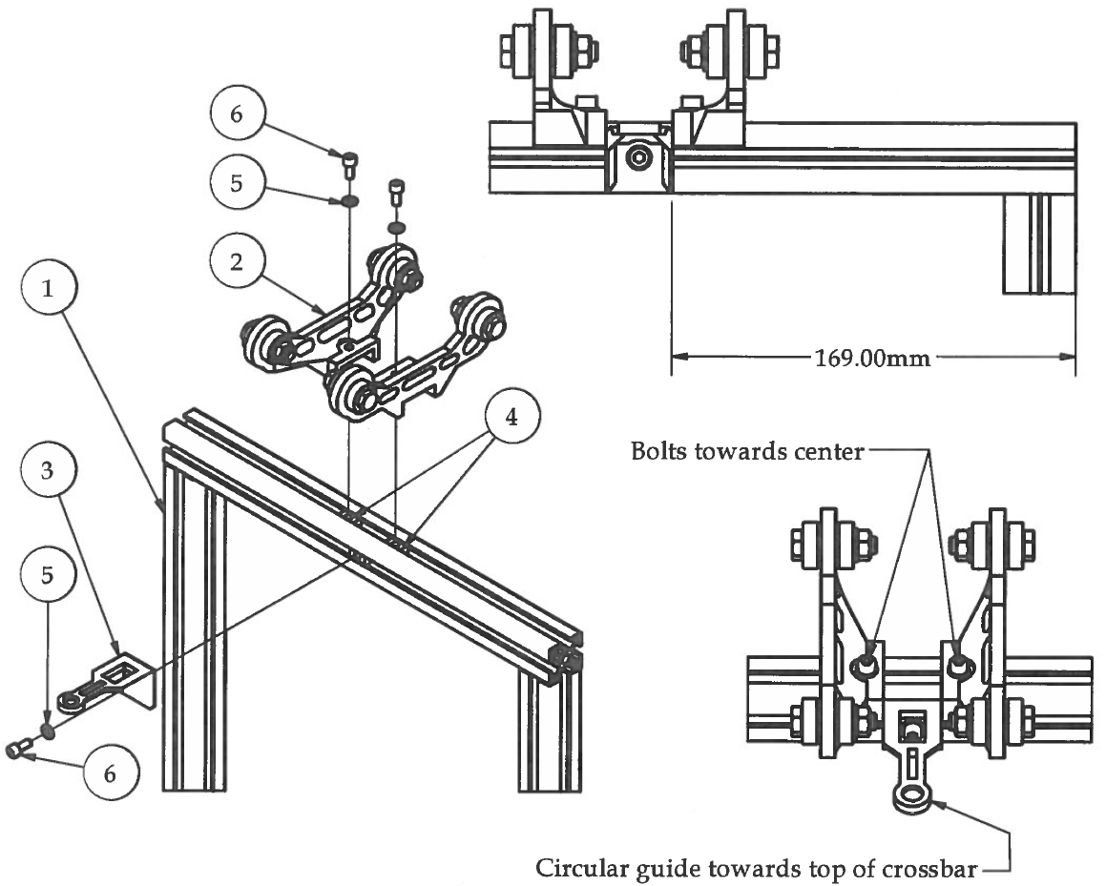Step 7

1. Insert 2 M5 T-Nuts into top slot and 1 M5 T-Nut into front slot of crossbar on upright frame. Install the filamentGuideV2 part measuring 169mm from outside of part to the outside of upright frame to center the part on the crossbar. Slide reelHolderSubAssembly parts onto the top of crossbar and tighten securely with M5 hardware.

|  |  |  |  |
| --- | --- | --- | --- |
| **PARTS LIST** | | | |
| **ITEM** | **QTY** | **PART NUMBER** | **DESCRIPTION** |
| 1 | 1 | Step 6 | Previous sub-assembly |
| 2 | 2 | reelHolderSubAssembly | Previous sub-assembly |
| 3 | 1 | filamentGuideV2 | 3D printed part |
| 4 | 3 | M5 T-Nut | Nuts and bolts |
| 5 | 3 | M5 Washer | Nuts and bolts |
| 6 | 3 | M5 x 12 | Nuts and bolts |
|  |  | M4 Hex Wrench | Tools |

# **Y Stage Assembly**

Step 1

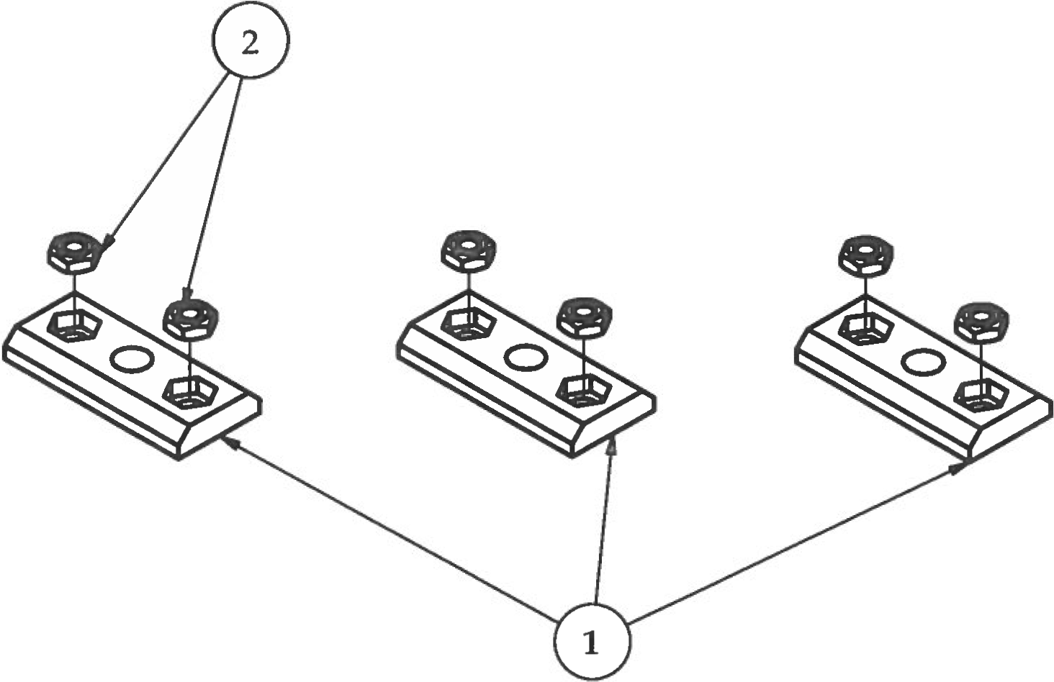

1. Press fit the M3 Hex Nuts into the hexagonal cavity on the ySlideRetainerV2 3D printed parts.

|  |  |  |  |
| --- | --- | --- | --- |
| **PARTS LIST** | | | |
| **ITEM** | **QTY** | **PART NUMBER** | **DESCRIPTION** |
| 1 | 3 | ySlideRetainerV2 | 3D printed part |
| 2 | 6 | M3 Hex Nut | Nuts and bolts |

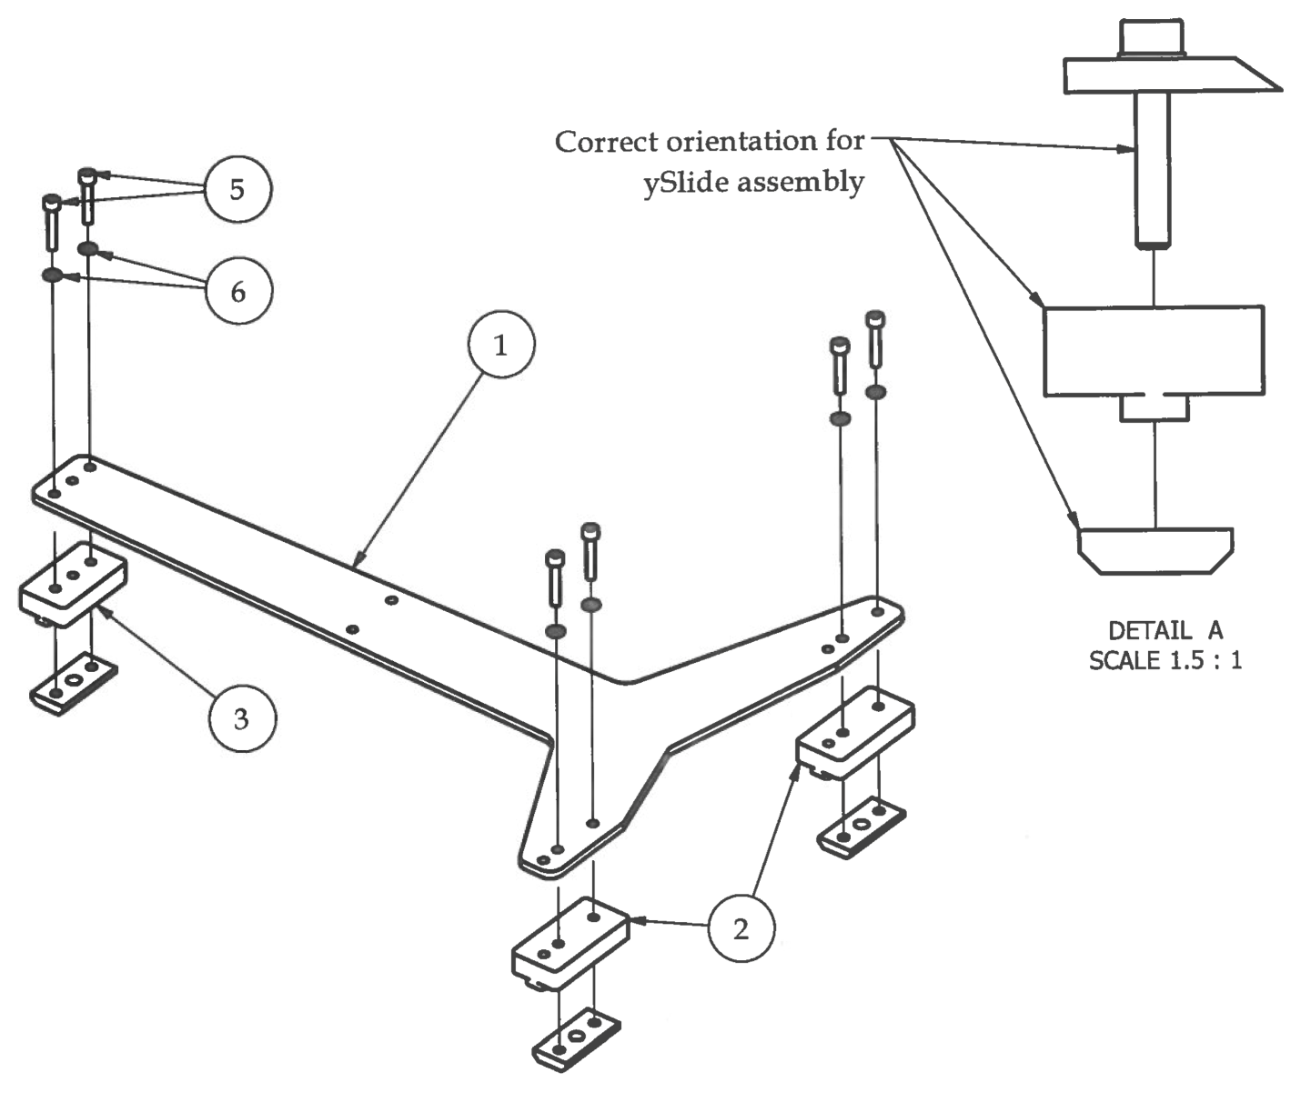Step 2

1. Attach the UHMW slides to the Y Carriage using M3 x 18 bolts.
2. Make sure that the holes on the slides match up to the holes on the yCarriage and that the ySlideRetainerV2 parts have the M3 Nuts facing downwards to lock all parts in together.

|  |  |  |  |
| --- | --- | --- | --- |
| **PARTS LIST** | | | |
| **ITEM** | **QTY** | **PART NUMBER** | **DESCRIPTION** |
| 1 | 1 | yCarriage_AL | Custom aluminum part |
| 2 | 2 | ySlideRight | Custom CNC milled part |
| 3 | 1 | ySlideLeft | Custom CNC milled part |
| 4 | 3 | Step1 | Previous sub-assembly |
| 5 | 6 | M3 x 18 | Nuts and bolts |
| 6 | 6 | M3 Washer | Nuts and bolts |
|  |  | M2.5 Hex Wrench | Tools |

1. Do not tighten M3 x 18 bolts all the way down until after calibrating the Y-Axis as shown in Step 4 of this assembly chapter.

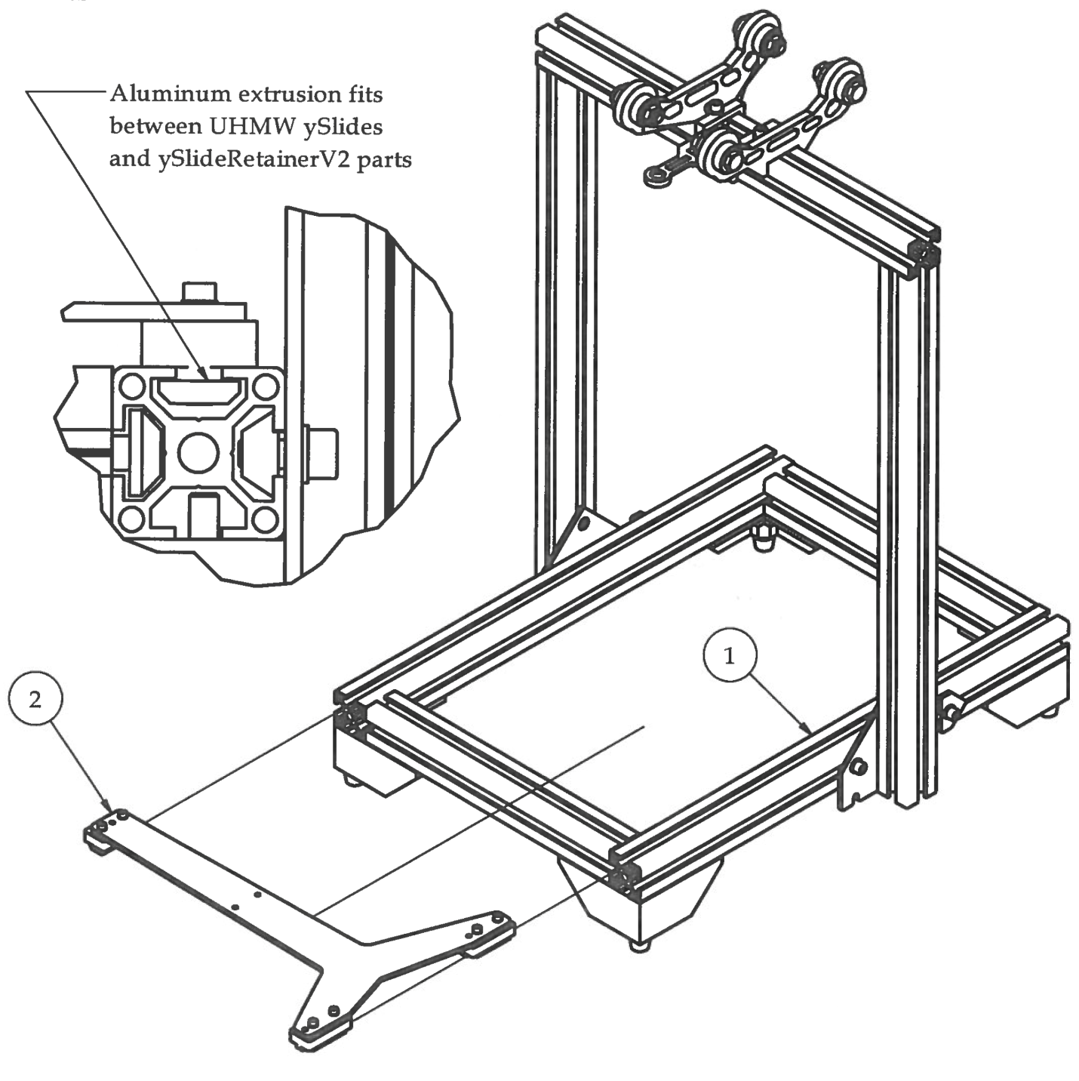Step 3

1. Carefully slide the Y Carriage into the top slots of aluminum extrusions on the bottom frame. The aluminum extrusion should fit between the UHMW ySlides and the ySlideRetainerV2s.
2. Move to the next step before tightening the M3 x 18 bolts!

|  |  |  |  |
| --- | --- | --- | --- |
| **PARTS LIST** | | | |
| **ITEM** | **QTY** | **PART NUMBER** | **DESCRIPTION** |
| 1 | 1 | flexMendelAssembly1 | Previous sub-assembly |
| 2 | 1 | Step2 | Previous sub-assembly |

Step 4 – Calibrating the Y-Axis

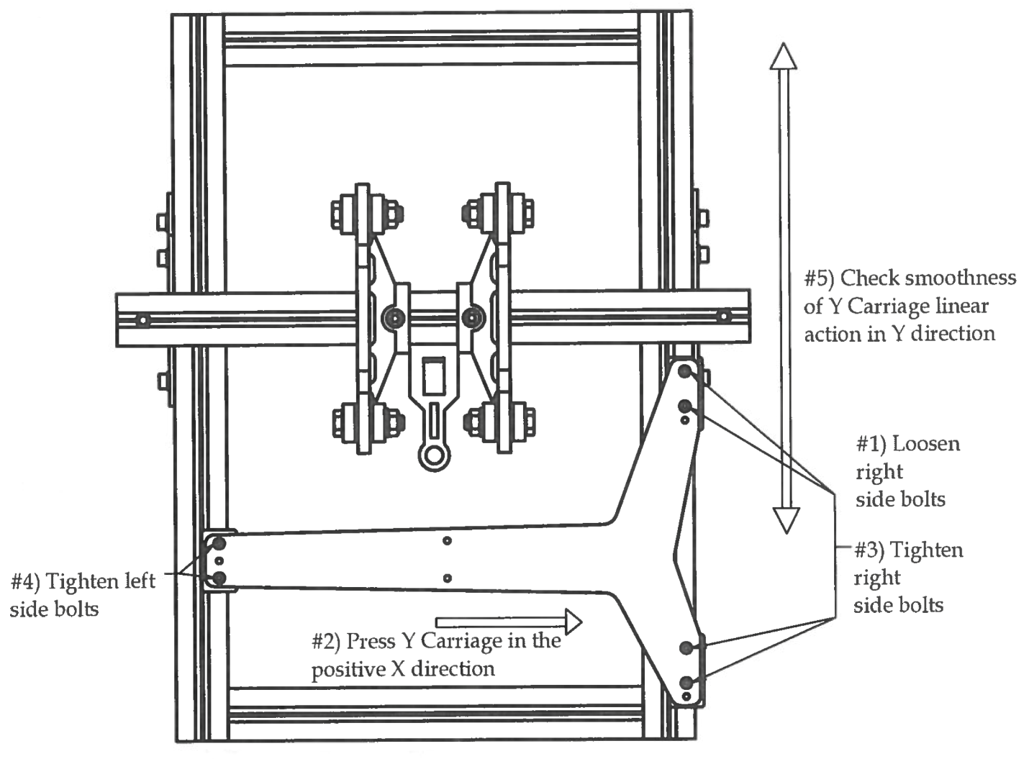

**Calibrating the Y-Axis:**

1. Loosen all M3 x 18 bolts that attach the Y Carriage to the Y Slides.
2. Press the entire Y Carriage in the positive X direction, thus aligning the two right ySlides against the right side of the top Y Right slot on the bottom frame.
3. Holding slight pressure on the Y Carriage towards the Y Right extrusion, tighten the M3 x 18 bolts on the right side first. Check linear action by sliding the Y carriage back and forth. It should be smooth and require no force to move it back and forth. If you feel any binding, go back to step 1 on this page and repeat the process.
4. When linear action is completely smooth after tightening right side M3 x 18 bolts, tighten left side M3 x 18 bolts.
5. Check linear action one more time. Movement of the Y Carriage should be completely unconstrained in Y direction.

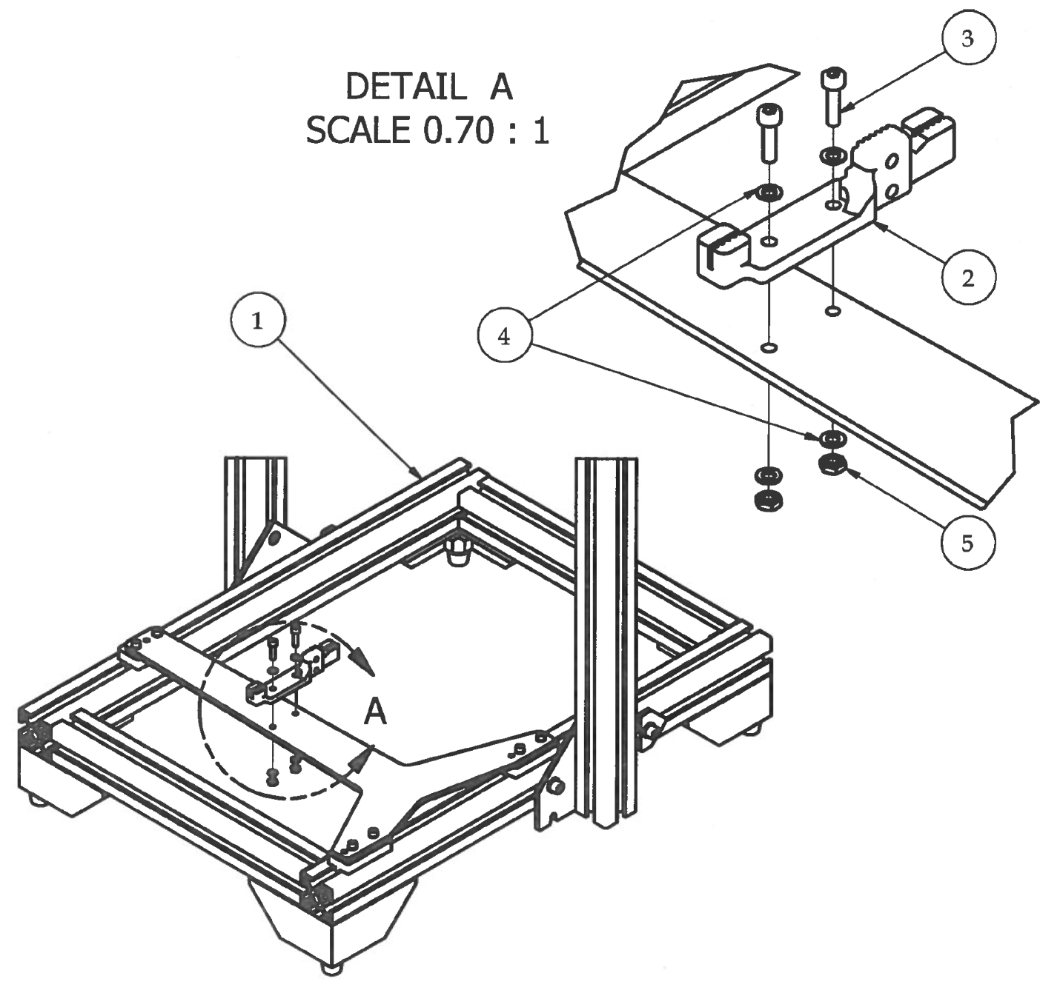Step 5

1. Attach the Y Belt Bracket with the longer feature sticking off the back of the Y Carriage.

|  |  |  |  |
| --- | --- | --- | --- |
| **PARTS LIST** | | | |
| **ITEM** | **QTY** | **PART NUMBER** | **DESCRIPTION** |
| 1 | 1 | Step 4 | Previous sub-assembly |
| 2 | 1 | yBeltBracketV2 | 3D printed part |
| 3 | 2 | M3 x 12 | Nuts and bolts |
| 4 | 4 | M3 Hex Nut | Nuts and bolts |
| 5 | 2 | M3 Hex Nut | Nuts and bolts |
|  |  | M2.5 Hex Wrench | Tools |

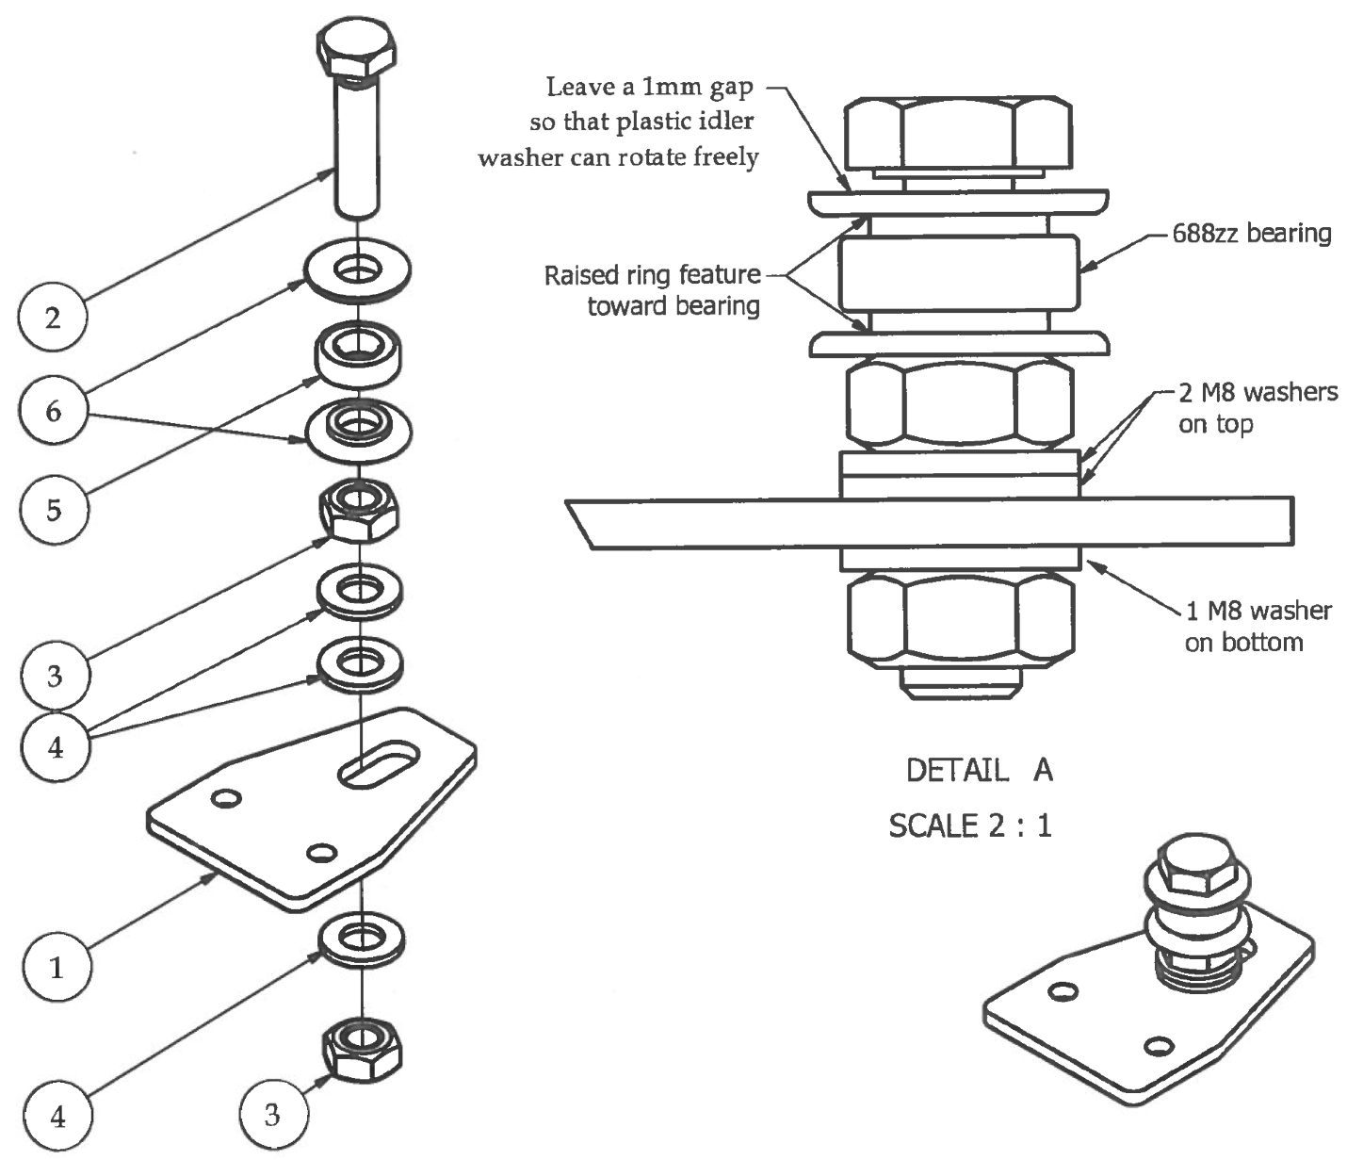Step 6

1. Assemble Y Idler Pulley as shown in the pictures. Do not tighten completely. Idler pulley should be able to move back and forth inside the slot on the yidlerBracket.
2. Be sure to face the 3D printed idlerPulleyWashers raised ring feature towards the 688zz bearing and to place 2 M8 washers on the top of Y Idler Aluminum bracket. This insures that the Y-belt will line up properly.

|  |  |  |  |
| --- | --- | --- | --- |
| **PARTS LIST** | | | |
| **ITEM** | **QTY** | **PART NUMBER** | **DESCRIPTION** |
| 1 | 1 | yIdlerBracket_AL | Custom aluminum part |
| 2 | 1 | M8 x 35 Hex Bolt | Nuts and bolts |
| 3 | 2 | M8 Hex Nut | Nuts and bolts |
| 4 | 3 | M8 Washer | Nuts and bolts |
| 5 | 1 | 688zz Bearing | Off-the-shelf component |
| 6 | 2 | idlerPulleryWasher | 3D printed part |

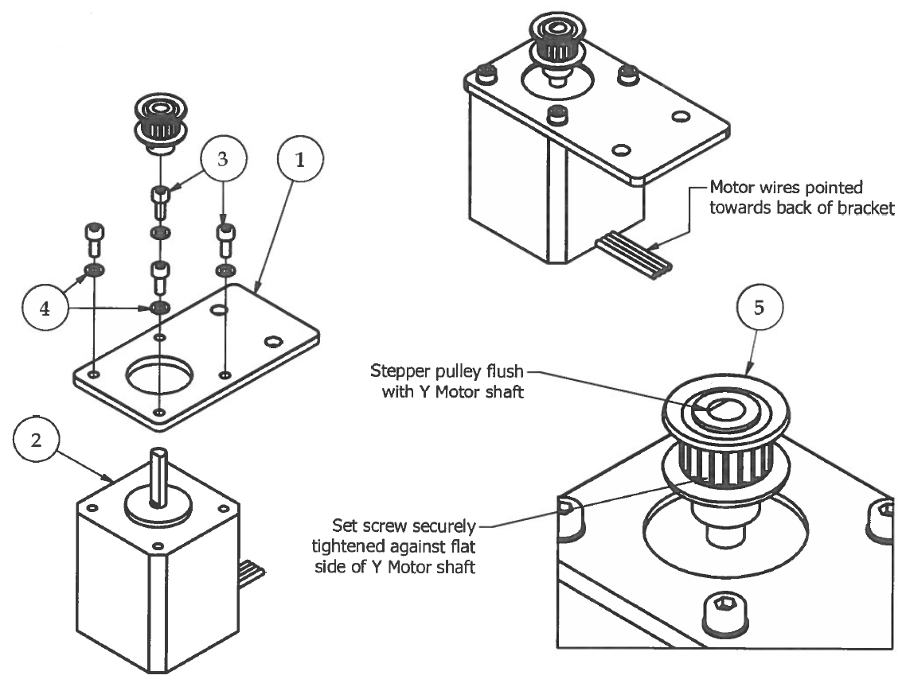Step 7

1. Attach Y Motor to Y Idler Bracket using M3 x 8 and M3 washers.
2. Make sure that Y Motor wires are pointing out towards the back of the bracket.

**\*\*\* Y Motor is the NEMA 17 stepper motor with 18" wire length\*\*\***

1. Attach 2GT 20 Tooth Stepper Puller to Y Motor shaft by tightening the setscrew inside the Pulley onto the flat side of the Y Motor shaft.

**\*\*\* Make sure that the top of the Stepper Pulley is flush with the top of the Y Motor shaft and make sure the setscrew is tightened down SECURELY.\*\*\***

|  |  |  |  |
| --- | --- | --- | --- |
| **PARTS LIST** | | | |
| **ITEM** | **QTY** | **PART NUMBER** | **DESCRIPTION** |
| 1 | 1 | yMotorBracket_AL | Custom aluminum part |
| 2 | 1 | NEMA 17 Stepper Motor | Electrical component |
| 3 | 4 | M3 x 8 | Nuts and bolts |
| 4 | 4 | M3 Washer | Nuts and bolts |
| 5 | 1 | 2GT 20 Tooth Stepper Pulley | Off-the-shelf component |
|  |  | M2.5 Hex Wrench | Tools |
|  |  | M1.5 Hex Wrench | Tools |

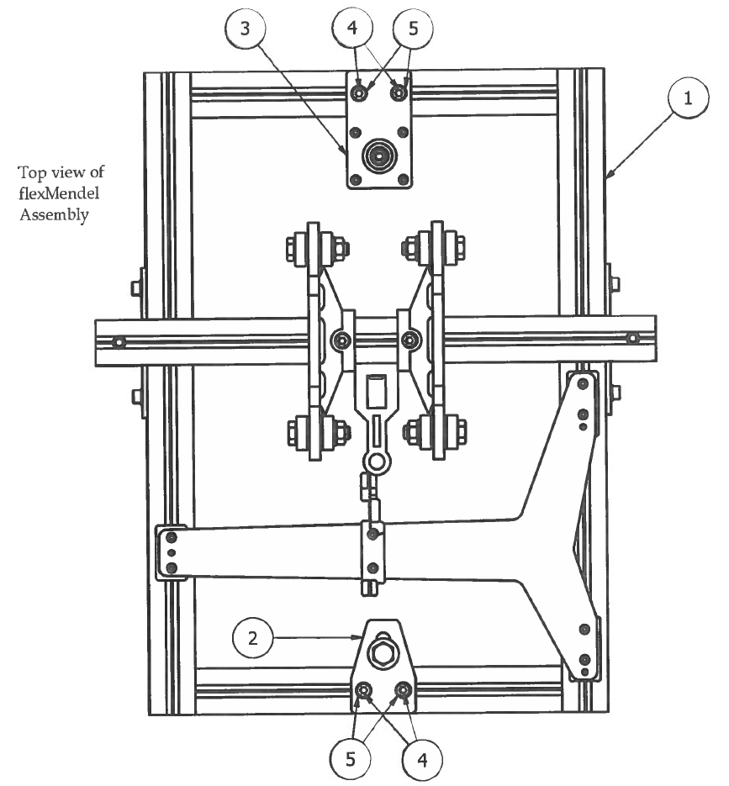Step 8

1. Loosely attach Y Idler Bracket and Y Motor Bracket sub-assemblies to the top slots of the front and back aluminum extrusions using M5 x 12 bolts, M5 washers, and the M5 T-Nuts that are already inside the top slots.

|  |  |  |  |
| --- | --- | --- | --- |
| **PARTS LIST** | | | |
| **ITEM** | **QTY** | **PART NUMBER** | **DESCRIPTION** |
| 1 | 1 | Step 5 | Previous sub-assembly |
| 2 | 1 | Step 6 | Previous sub-assembly |
| 3 | 1 | Step 7 | Previous sub-assembly |
| 4 | 4 | M5 x 12 | Nuts and bolts |
| 5 | 4 | M5 Washer | Nuts and bolts |

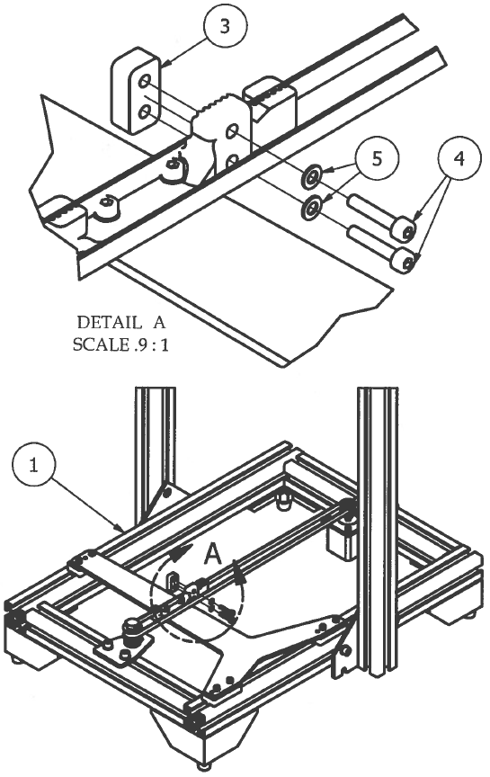Step 9

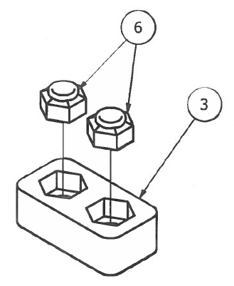

1. Press fit 2 M3 Nylock Nuts into the hex cavities in the yBeltBracket 3D printed part. Make sure the Nylock lip is facing towards the outside of the clamp.
2. Slide the 690mm belt over the Y motor pulley and the Y idler pulley. Carefully squeeze the LEFT SIDE of the 690mm belt into the grooved slot on the yBeltBracket 3D printed part. The teeth on the belt should fit tight into the grooves on the yBeltBracket.
3. Securely attach the yBeltBracketClampV2 to the yBeltBracket using M3 x 16 bolts and M3 washers.

|  |  |  |  |
| --- | --- | --- | --- |
| **PARTS LIST** | | | |
| **ITEM** | **QTY** | **PART NUMBER** | **DESCRIPTION** |
| 1 | 1 | Step 8 | Previous sub-assembly |
| 2 | 1 | 2GT Belt 690mm | Off-the-shelf component |
| 3 | 1 | yBeltBracketClampV2 | 3D printed part |
| 4 | 2 | M3 x 16 | Nuts and bolts |
| 5 | 2 | M3 Washer | Nuts and bolts |
| 6 | 2 | M3 Nylock Nut | Nuts and bolts |
|  |  | M2.5 Hex Wrench | Tools |

1. Proceed to the next step for aligning the Y-Belt with the Y motor and the Y Idler.

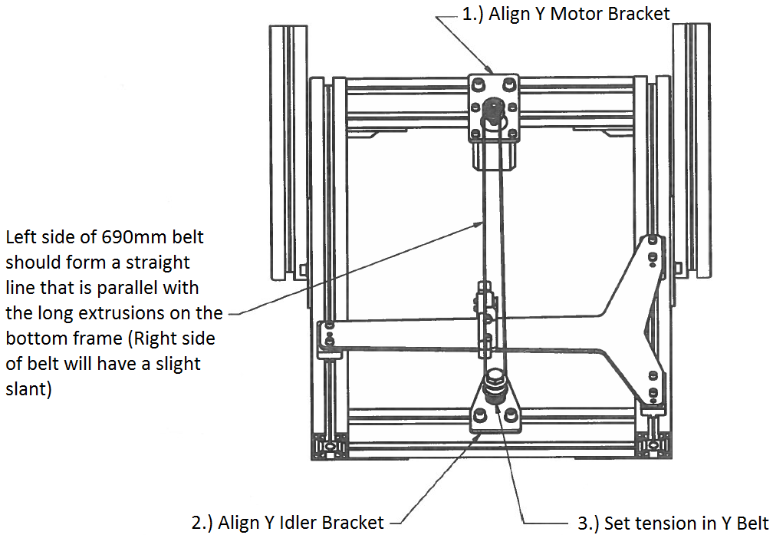Step 10

1. Rotate the flexMendel 30 printer so the front is facing directly towards you.
2. Using one eye (preferably your good eye) look down the LEFT SIDE of the 690mm belt.
3. Loosen (if not already) the M5 x 12 bolts that fasten the yidlerBracket and the yMotorBracket to the bottom frame.
4. Start with the YMotorBracket first. Look down the LEFT SIDE of the 690mm belt. Position the yMotorBracket so that the left side of the belt becomes a perfectly straight line. You may need to pull on the yidlerBracket a little bit to increase tension in the belt.
5. When it is perfectly lined up on the left side, tighten the M5 x 12 bolts on the yMotorBracket securely.
6. Repeat this process for the yidlerBracket using your eye to line up the left side of the belt in a perfectly sfraight line.
7. Tighten the MS x 12 bolts on the yidlerBracket.
8. Adjust the tension of the Y Belt by pulling the Y Idler towards the front of the flexMendel 30 printer. DO NOT APPLY TOO MUCH TENSION ON THE BELT! The tension should be tight enough that holds a straight line when taut, but not so tight that it constrains the movement of the Y Carriage.
9. Using 213mm Cresent Wrenches, tighten the 2 MS Nuts on the Y Idler Pulley sub-assembly to secure the idler in position. Check the smoothness of the Y Carriage by moving it back and forth. If there is too much tension on the belt, you will feel heavy resistance in the motion. If this happens, loosen the 2 M8 Nuts, re-adjust the tension, and tighten again. Do not move onto the next step until this is complete.

# **Z Stage Assembly**

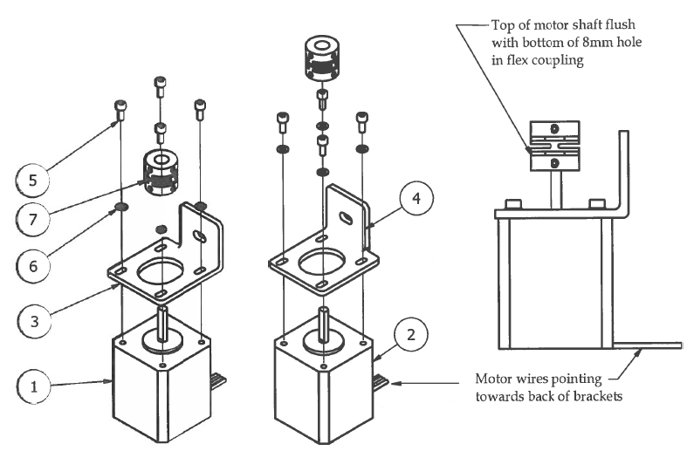Step 1

Pointing towards back of brackets

Motor wires

Top of motor shaft flush with bottom of 8mm hole in flex coupling

1. Attach Left Z Motor (1011 wire length) to zMotorBracketLeft with M3 hardware. Make sure that the motor wires are pointing out towards the back of the bracket.
2. Right Z Motor (2011 wire length) to zMotorBracketRight with M3 hardware.
3. Insert motor shafts into 5mm hole on flex couplings and line up the top of the motor shaft with the bottom of the 8mm hole.
4. Securely tighten lower set screw to flat side of motor shaft.
5. Tighten additional lower set screw to motor shaft for extra support.

|  |  |  |  |
| --- | --- | --- | --- |
| **PARTS LIST** | | | |
| **ITEM** | **QTY** | **PART NUMBER** | **DESCRIPTION** |
| 1 | 1 | Left Z Motor NEMA 17 | Electrical components |
| 2 | 1 | Right Z Motor NEMA 17 | Electrical components |
| 3 | 1 | zMotorBracketLeft | Custom aluminum parts |
| 4 | 1 | zMotorBraacketRight | Custom aluminum parts |
| 5 | 8 | M3 x 8 | Nuts and bolts |
| 6 | 8 | M3 Washer | Nuts and bolts |
| 7 | 2 | Flex Coupling Resin Type | Off-the-shelf components |
|  |  | M2.5 Hex Wrench | Tools |
|  |  | M1.5 Hex Wrench | Tools |

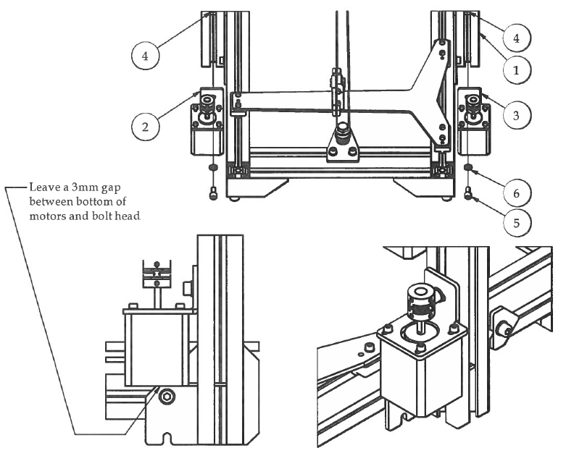Step 2

1. Slide M5 T-Nuts into front slots of upright frame extrusions.
2. Attach Z Motor sub-assemblies to the upright frames using MS hardware.
3. Position the bottom of the Z motors about 3mm above the head of the bolt that attaches the Z Brackets to bottom frame.

|  |  |  |  |
| --- | --- | --- | --- |
| **PARTS LIST** | | | |
| **ITEM** | **QTY** | **PART NUMBER** | **DESCRIPTION** |
| 1 | 1 | yStageAssembly | Previous sub-assembly |
| 2 | 1 | Step1.1 | Previous sub-assembly |
| 3 | 1 | Step1.2 | Previous sub-assembly |
| 4 | 2 | M5 T-Nut | Nuts and bolts |
| 5 | 2 | M5 x 12 | Nuts and bolts |
| 6 | 2 | M5 Washer | Nuts and bolts |
|  |  | M4 Hex Wrench | Tools |

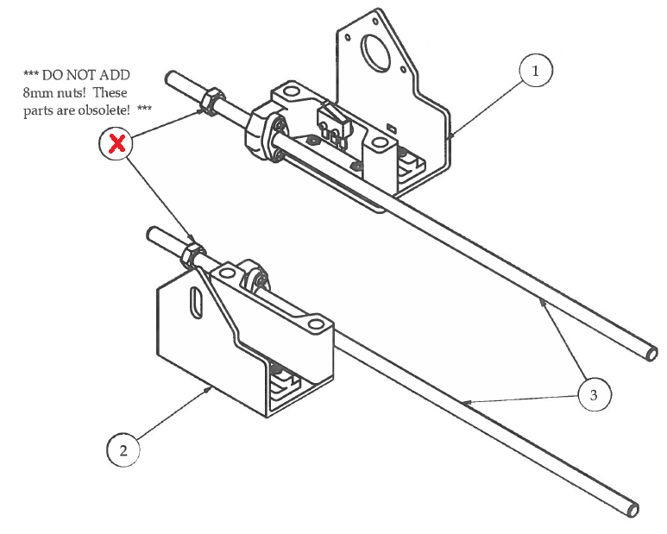Step 3

1. Thread the 8mm threaded rods onto the X Motor and X Idler sub-assemblies. leaving about a 50mm of the threaded rods sticking out toward the top.

|  |  |  |  |
| --- | --- | --- | --- |
| **PARTS LIST** | | | |
| **ITEM** | **QTY** | **PART NUMBER** | **DESCRIPTION** |
| 1 | 1 | xStageMotorSubAssembly | Previous sub-assembly |
| 2 | 1 | xStageIdlerSubAssembly | Previous sub-assembly |
| 3 | 2 | M8 Threaded Rod 380mm | Off-the-shelf component |

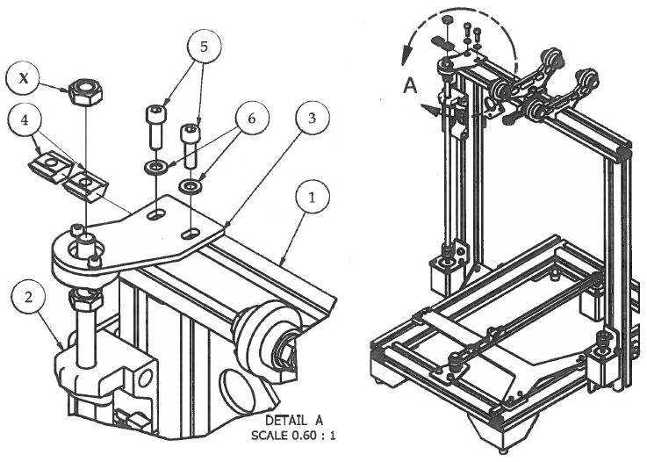Step 4

1. Slide the bottom of the Z Rod sub-assembly into the top of the flex coupling on the left side of the flexMendel.
2. Carefully move into upright position by inserting the Z Slides from inside the xStageSupportMotor sub-assembly into the outer slots of the left-side upright frame.
3. Insert the top of the threaded rod into the hole on the bearing in the zRodSupportLeft assembly and mount to the top crossbar using M5 hardware. **DO NOT FASTEN TIGHTLY!!!** We will come back to this subassembly when calibrating the Z Axis.
4. **\*\*\* DO NOT ADD 8mm nuts! These parts are obsolete! \*\*\***

|  |  |  |  |
| --- | --- | --- | --- |
| **PARTS LIST** | | | |
| **ITEM** | **QTY** | **PART NUMBER** | **DESCRIPTION** |
| 1 | 1 | Step2 | Previous sub-assembly |
| 2 | 1 | Step3.1 | Previous sub-assembly |
| 3 | 1 | zRodSupportAssyLeft | Previous sub-assembly |
| 4 | 2 | M5 T-Nuts | Nuts and bolts |
| 5 | 2 | M5 x 12 | Nuts and bolts |
| 6 | 2 | M5 Washer | Nuts and bolts |
|  |  | M4 Hex Wrench | Tools |

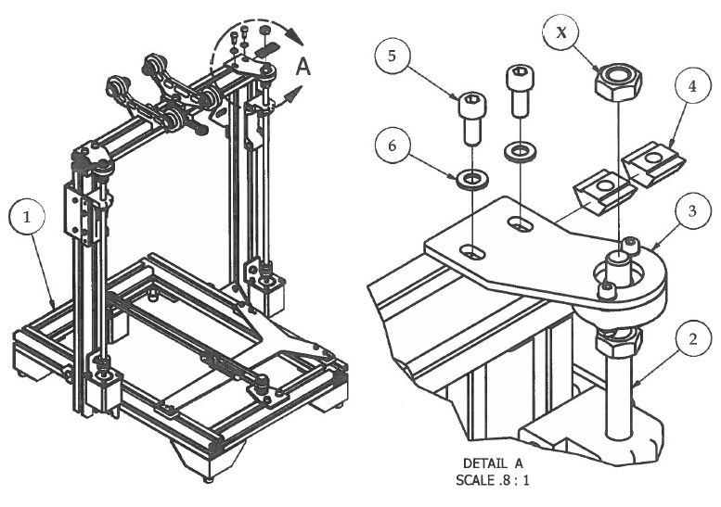Step 5

1. Slide the bottom of the Z Rod sub-assembly into the top of the flex coupling on the right side of the flexMendel.
2. Carefully move into upright position by inserting the Z Slides from inside the xStageSupportldler sub-assembly into the outer slots of the right-side upright frame.
3. Insert the top of the threaded rod into the hole on the bearing in the zRodSupportRight assembly and mount to the top crossbar using M5 hardware. **DO NOT FASTEN TIGHTLY!!!** We will come back to this subassembly when calibrating the Z-Axis.
4. **\*\*\* DO NOT ADD 8mm nuts! These parts are obsolete! \*\*\***

|  |  |  |  |
| --- | --- | --- | --- |
| **PARTS LIST** | | | |
| **ITEM** | **QTY** | **PART NUMBER** | **DESCRIPTION** |
| 1 | 1 | Step4 | Previous sub-assembly |
| 2 | 1 | Step3.2 | Previous sub-assembly |
| 3 | 1 | zRodSupportAssyLeft | Previous sub-assembly |
| 4 | 2 | M5 T-Nuts | Nuts and bolts |
| 5 | 2 | M5 x 12 | Nuts and bolts |
| 6 | 2 | M5 Washer | Nuts and bolts |
|  |  | M4 Hex Wrench | Tools |

|  |  |  |  |
| --- | --- | --- | --- |
| **PARTS LIST** | | | |
| **ITEM** | **QTY** | **PART NUMBER** | **DESCRIPTION** |
|  |  | M1.5 Wrench | Tools |

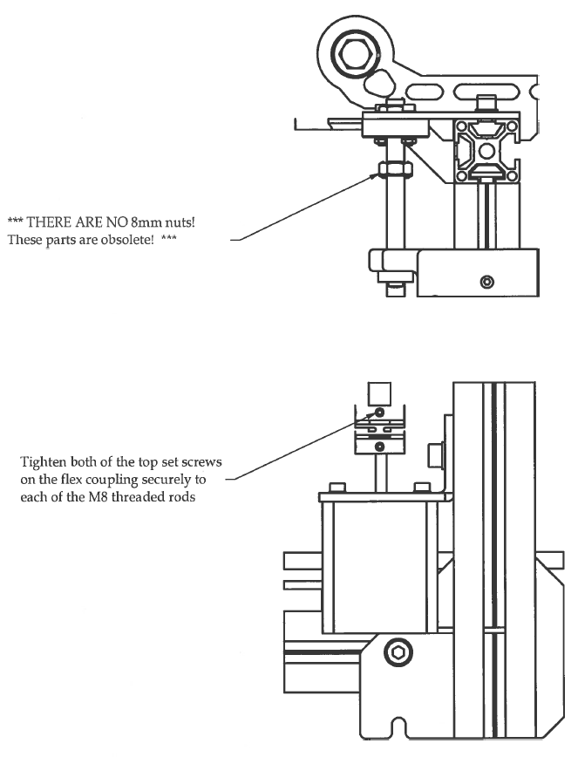Step 6

# **X Stage Assembly**

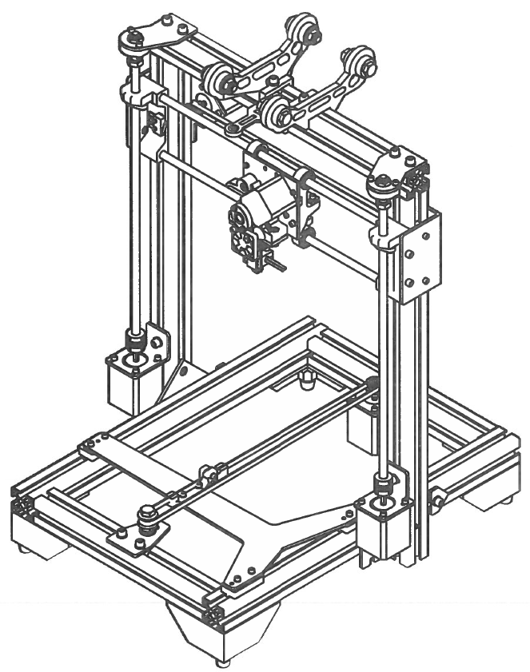

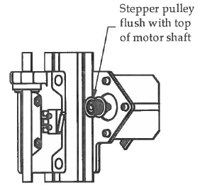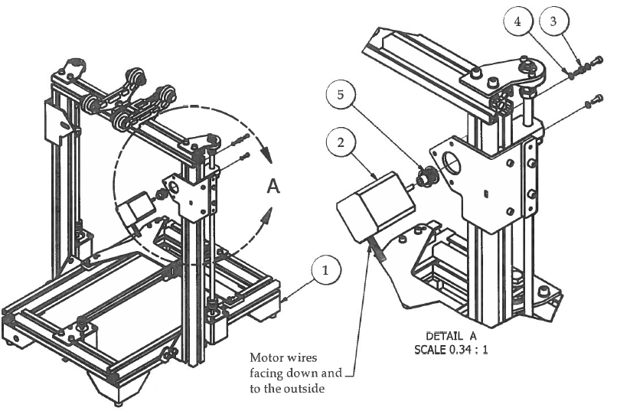Step 1

1. Attach the X Motor to the xMotorBracket using M3 hardware.
2. Make sure the wires from the X Motor are pointed down and towards the outside of the flexMendel.
3. Attach Stepper Pulley to motor shaft with the top of the pulley flush with the top of the motor shaft.
4. Tighten the set screw on the pulley securely to the flat side of the motor shaft.

|  |  |  |  |
| --- | --- | --- | --- |
| **PARTS LIST** | | | |
| **ITEM** | **QTY** | **PART NUMBER** | **DESCRIPTION** |
| 1 | 1 | zStageAssembly | Previous sub-assembly |
| 2 | 1 | X Motor NEMA 17 | Electrical components |
| 3 | 3 | M3 x 8 | Nuts and bolts |
| 4 | 3 | M3 Washer | Nuts and bolts |
| 5 | 1 | 2GT 20 Tooth Stepper Pulley | Off-the-shelf components |
|  |  | M1.5 Hex Wrench | Tools |
|  |  | M2.5 Hex Wrench | Tools |

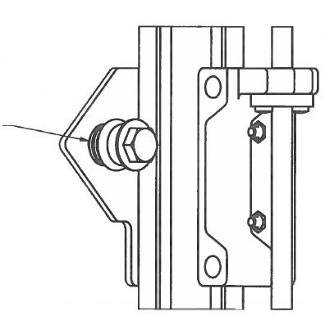Step 2

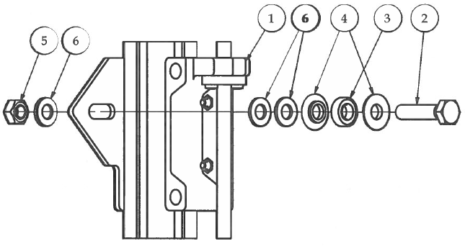

Leave finger tight for belt assembly adjustments

|  |  |  |  |
| --- | --- | --- | --- |
| **PARTS LIST** | | | |
| **ITEM** | **QTY** | **PART NUMBER** | **DESCRIPTION** |
| 1 | 1 | Step1 | Previous sub-assembly |
| 2 | 1 | M8 x 35 Hex Bolt | Nuts and bolts |
| 3 | 1 | 688zz Bearing | Off-the-shelf-components |
| 4 | 2 | idlerPulleyWaher | 3D printed parts |
| 5 | 2 | M8 Hex Nut | Nuts and bolts |
| 6 | 3 | M8 Washer | Nuts and bolts |

1. Attach the X Idler assembly to the X Idler Bracket.

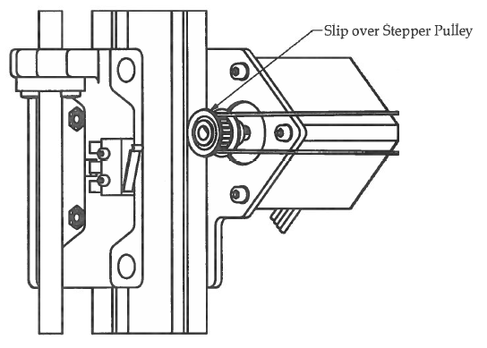Step 3

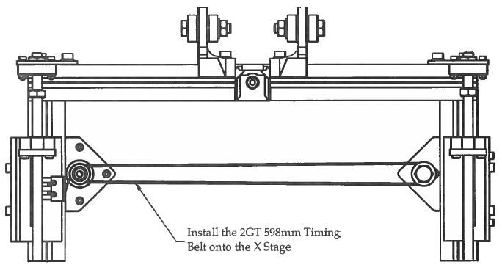

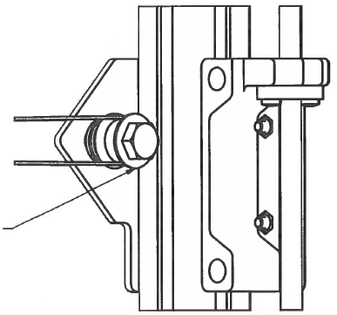

1. Slip timing belt over Idler Pulley
2. Set belt tension by pressing the M8 bolt towards the outside of the frame, tightening the belt. DO NOT OVER TIGHTEN!!!
3. Use 213mm Cresent Wrenches to tighten M8 hardware to secure X Idler Pulley in place.

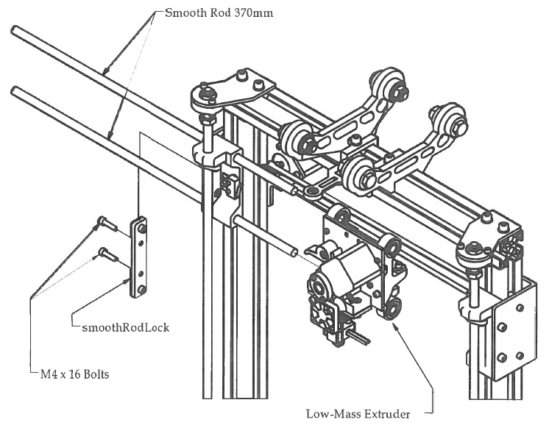Step 4

1. Remove the 2 M4 bolts and the smoothRodLock from the X Motor Bracket.
2. Slide a 370mm Smooth Rod in from the outside of the frame, through the two 8mm bushings on the top of the Low-Mass Extruder, and all the way in to the adjacent hole on the X Idler Bracket.
3. Repeat with the other 370mm Smooth Rod attaching the bottom bushings of the Low-Mass Extruder.
4. Replace the smoothRodLock and the two M4 bolts on the outside of the X Motor Bracket.

|  |  |  |  |
| --- | --- | --- | --- |
| **PARTS LIST** | | | |
| **ITEM** | **QTY** | **PART NUMBER** | **DESCRIPTION** |
| 1 | 1 | Step3 | Previous sub-assembly |
| 2 | 2 | Smooth Rod 370mm | Off-the-shelf component |
| 3 | 1 | LowMassExtruderAssembly | Previous sub-assembly |
|  |  | M3 Hex Wrench | Tools |

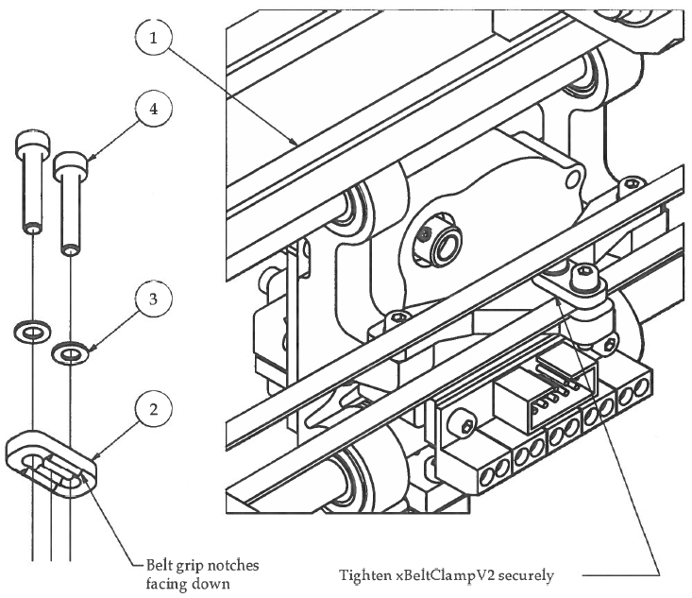Step 5

1. Prepare xBeltClampV2 for attachment with M3 hardware with the belt grip notches facing down as shown in the picture to the left.
2. Place the X Belt in between the xBeltBracket and the xBeltClampV2 located on the back of the Low­ Mass Extruder.
3. Tighten M3 hardware on xBeltClampV2 securely to the xBeltBracket.

|  |  |  |  |
| --- | --- | --- | --- |
| **PARTS LIST** | | | |
| **ITEM** | **QTY** | **PART NUMBER** | **DESCRIPTION** |
| 1 | 1 | Step4 | Previous sub-assembly |
| 2 | 1 | xBeltBracketClampV2 | 3D printed part |
| 3 | 2 | M3 Washer | Nuts and bolts |
| 4 | 2 | M3x12 | Nuts and bolts |
|  |  | M2.5 Hex Wrench | Tools |